THIS IS A DECISION PAPER

TO: HARDIN COUNTY BOARD OF EDUCATION

FROM: Teresa Morgan, Superintendent

DATE: February 22, 2024

SUBJECT: APPROVE Revised BG 1 and Construction Contract for the Early Learning Academy North End

ISSUE: KDE requires a BG 1 for Renovations

FACTS
After aggressively negotiating with T and T Construction, it is time to approve the necessary paperwork to begin the project.

Revised BG 1



T and T Contract
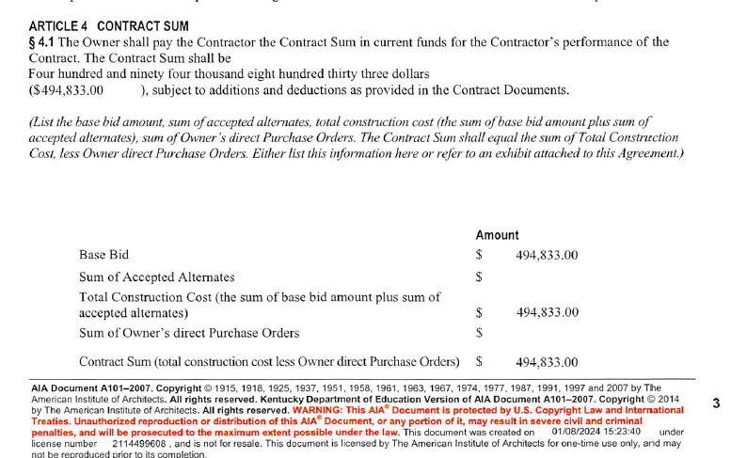

*See Attached

RECOMMENDATION
I RECOMMEND THE BOARD approve the Revised bG1 and T and T Construction Contract for the Renovation of the Early Learning Academy North End.

RECOMMENDED MOTION

I MOVE THE BOARD approve the Revised bG1 and T and T construction Contract for the Renovation of the Early Learning Academy North End.

