THIS IS A DECISION PAPER

TO: HARDIN COUNTY BOARD OF EDUCATION

FROM: teresa morgan, Superintendent

DATE: February 22, 2024

SUBJECT: APPROVAL OF CHANGE ORDERS 97-100 FOR THE CHHS PHASE 1 CONSTRUCTION PROJECT

ISSUE:
Change Order 97 is a credit of $ 3,000 and is for leftover fill dirt placement. Change Order 98-100 are debits of $ 4,040.70, $ 2,401.75, and $ 2,626.38 totaling 9,068.83. They are costs associated with additional supports for display/trophy cases and drywall around sprinkler heads under stairs.

FACTS:

CO 97

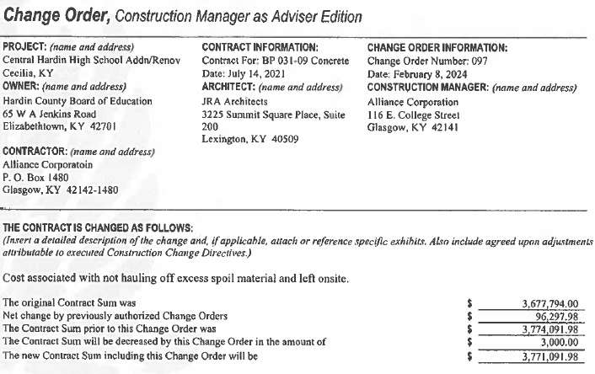

CO 98
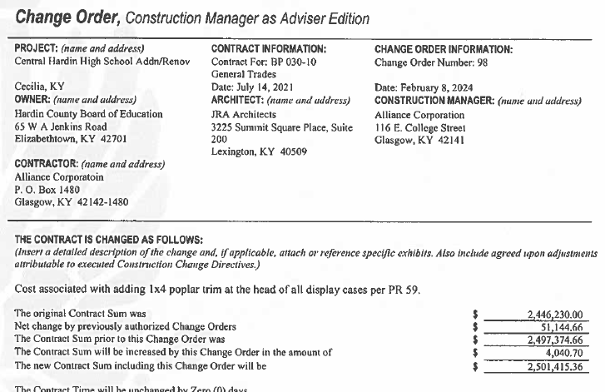

CO 99

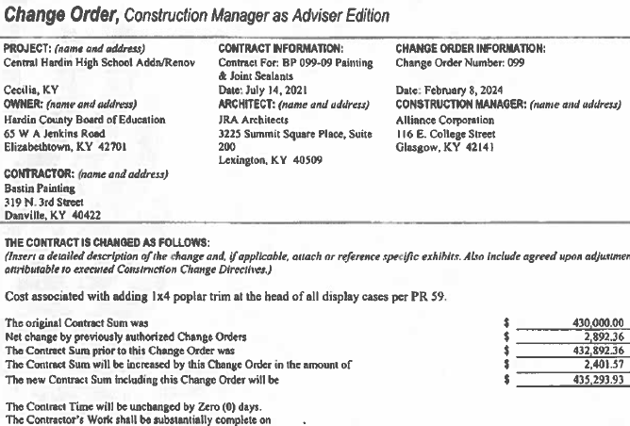

CO 100

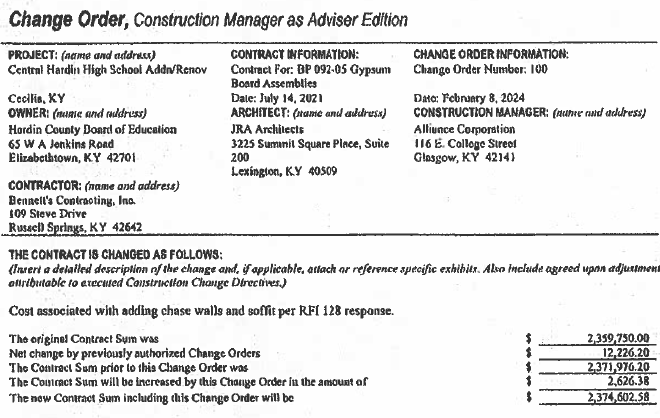

RECOMMENDATION
I RECOMMEND THE BOARD APPROVE CHANGE ORDERs 97-100 for the CHHS Phase 1 Construction project.

RECOMMENDED MOTION
I MOVE THE BOARD APPROVE CHANGE ORDERs 97-100 for the CHHS Phase 1 Construction project.

