THIS IS A DECISION PAPER

TO: HARDIN COUNTY BOARD OF EDUCATION

FROM: Teresa Morgan, Superintendent

DATE: February 22, 2024

SUBJECT: APPROVAL OF CHANGE ORDER 8 SITE FOR THE JHHS TURF PROJECT

ISSUE:
Change Order 8 is a debit of $ 6,325 and is for a drainage pipe to be installed under the access road to allow water to migrate off-site.

FACTS:

CO 8 Site JHHS

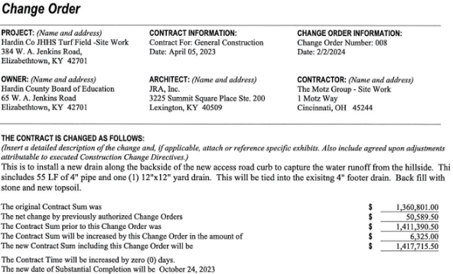

RECOMMENDATION
I RECOMMEND THE BOARD APPROVE CHANGE ORDER 8 for the JHHS turf project.

RECOMMENDED MOTION
I MOVE THE BOARD APPROVE CHANGE ORDER 8 for the JHHS Turf project.

