THIS IS A DECISION PAPER

TO: HARDIN COUNTY BOARD OF EDUCATION

FROM: TERESA MORGAN, Superintendent

DATE: January 18, 2024

SUBJECT: SFCC OFFER OF ASSISTANCE FOR FACILITIES CONSTRUCTION

ISSUE: Hardin County must respond to the attached offer of assistance within 30 days from the FSCC

FACTS:

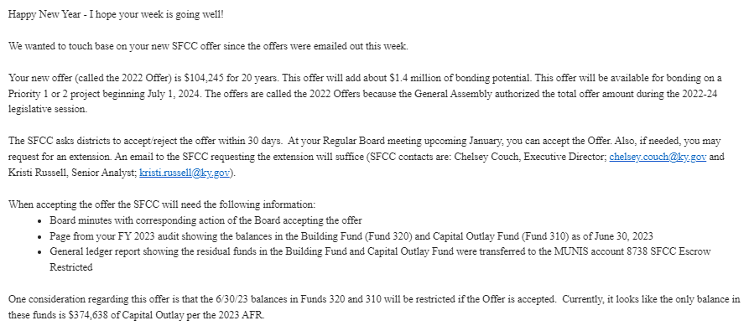

RECOMMENDATION:
i recommend that the Hardin County Board of Education accept the SFCC Offer of Assistance for Construction to the Hardin County Schools.

RECOMMENDED MOTION
I MOVE THAT the Hardin County Board of Education accept the SFCC Offer of Assistance for Construction to the Hardin County Schools.

