THIS IS A DECISION PAPER

TO: HARDIN COUNTY BOARD OF EDUCATION

FROM: Teresa Morgan, Superintendent

DATE: JANUARY 18, 2024

SUBJECT: APPROVE BG 1 HVAC REPAIR OLD LT

ISSUE: The cooler and boiler at the old Lincoln Trail need to be replaced.

FACTS

FACTS:

All are the same tower (BAC) and have a 14-16 week lead time.
Cooler Boiler Total
CPS- $247,792 $ 93,576 $ 341,368
Knights- $258,940 $ 158,000 $ 416,940

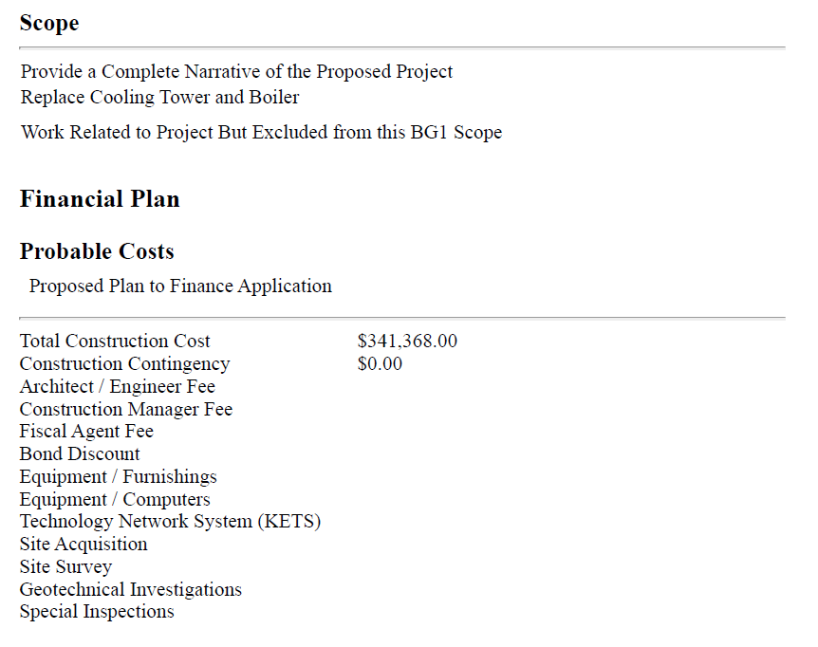

RRECOMMENDATION
I RECOMMEND THE hardin county BOARD of education approve the BG 1 for HVAC repairs to the old LT.

RECOMMENDED MOTION

I MOVE THE hardin county BOARD of education approve the BG 1 for hvac repairs to the old lt.

