THIS IS A DECISION PAPER

TO: HARDIN COUNTY BOARD OF EDUCATION

FROM: Teresa Morgan, Superintendent

DATE: January 18, 2024

SUBJECT: APPROVAL OF CHANGE ORDERS 93-95 FOR THE CHHS PHASE 1 CONSTRUCTION PROJECT

ISSUE:
Change Orders 93-95 are debits of $ 1,010.85, $ 993.54, and $ 2,000 totaling 4,004.39. They are costs associated with additional fireproofing along big gym walls and locker room privacy screens.

FACTS:

CO 93

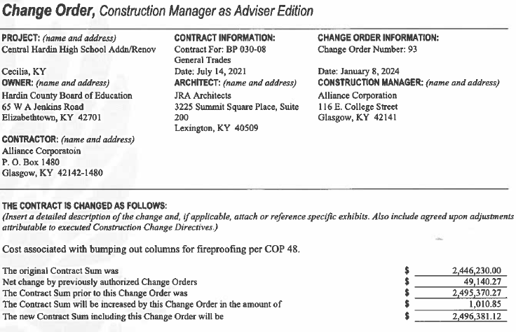

CO 94

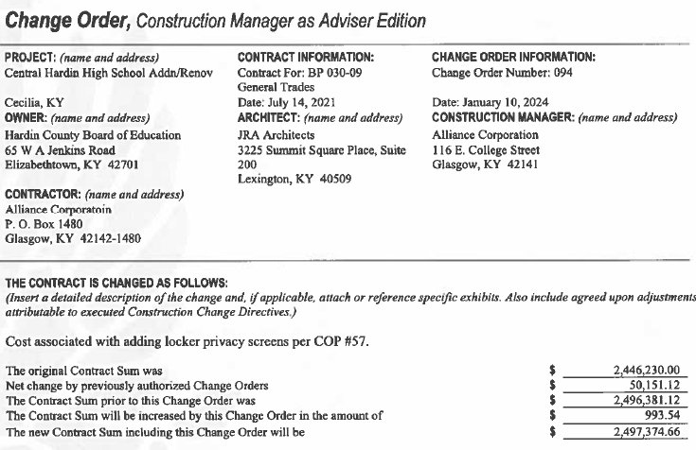

CO 95

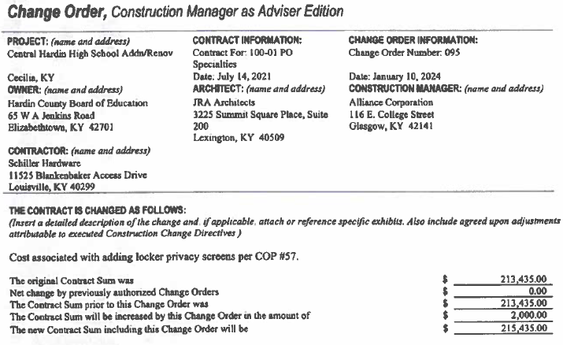

RECOMMENDATION
I RECOMMEND THE hardin county BOARD of education APPROVE CHANGE ORDERs 93-95 for the CHHS Phase 1 Construction project.

RECOMMENDED MOTION
I MOVE THE hardin county BOARD of education APPROVE CHANGE ORDERs 93-95 for the CHHS Phase 1 Construction project.

