THIS IS A DECISION PAPER

TO: HARDIN COUNTY BOARD OF EDUCATION

FROM: TERESA MORGAN, Superintendent

DATE: DECEMBER 21, 2023

SUBJECT: CHHS PHASE II CONSTRUCTION PROJECT

ISSUE: CONSIDERATION OF CHHS PHASE II CONSTRUCTION BIDS

FACTS:

KDE requires boards to approve construction bids to proceed with a project. There were no bids for bid package 7 (Aluminum Framed Entrances). Codell representatives are actively looking for a sub-contractor to perform that scope of work. Total Construction Cost less the aluminum framed entrances totaled $ 39,420,417.

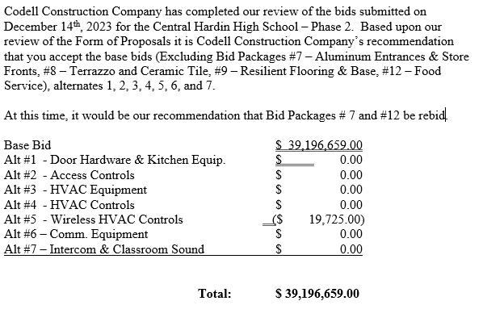

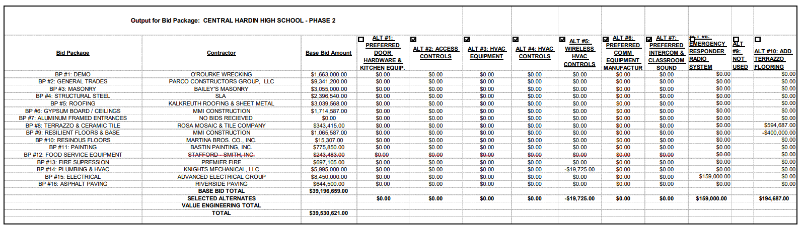

*See attached Docments

RECOMMENDATION:

i recommend that the Board award contracts for bid packages 1-6, 11, 13-16 and accept alternates 1-7 as recommended by CODell and JRA for the chhs phase II construction project. In addition, the board rejects the bid by Stafford Smith for bid package 12, asks for a revised scope, and directs Codell to put Bid packages 7 and 12 out for rebid.

RECOMMENDED MOTION
i move that the Board award contracts for bid packages 1-6, 11, 13-16 and accept alternates 1-7 as recommended by CODell and JRA for the chhs phase II construction project. In addition, the board rejects the bid by Stafford Smith for bid package 12, asks for a revised scope, and directs Codell to put Bid packages 7 and 12 out for rebid.

