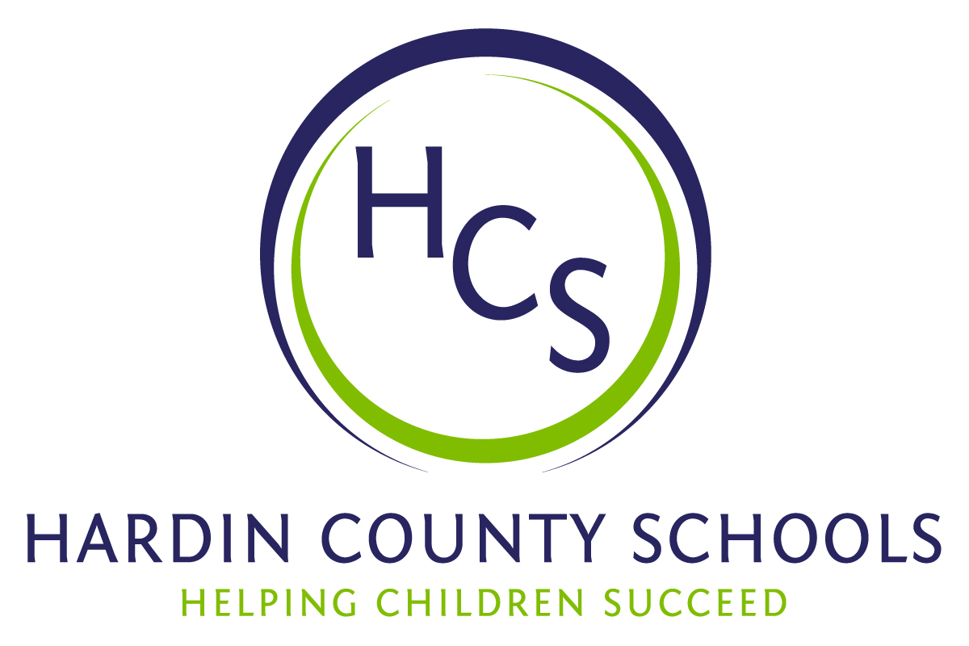
Board of Education
Dawn Johnson, Chair
Ben Sego, Vice Chair
Steve Bland
Mark Casey
Charlie Wise

Chief Academic Officer
Greg Sutton
Chief Operations Officer
John Stith

Teresa Morgan, Superintendent

Resolution of Recognition
#HCSBetterTogether Award

WHEREAS, the function of a Board of Education is to strive for excellence in all phases of educational programs, and;

WHEREAS, the Hardin County Board of Education deems it fitting and proper that significant awards and honors be recognized by the Board, and;

WHEREAS, the Hardin County Board of Education believes in work ethic and the ability of students, staff, and community members who dedicate themselves totally to the education of our next generation of leaders, and;

WHEREAS, the district’s theme for the 2023-24 school year is #HCSBetterTogether and the Hardin County Board of Education believes in these characteristics so greatly that it will recognize HCS students & staff and Hardin County community members at its regularly scheduled meeting each month during the school year with the #HCSBetterTogether Award;

BE IT THEREFORE RESOLVED THAT the Hardin County Board of Education, in a regular meeting on December 21, 2023, does hereby recognize the following for earning the #HCSBetterTogether Award for December 2023:

- Andres Jenkins, a North Hardin High School senior, is a very active volunteer in his school’s Youth Service Center, participates in three sports, and is taking classes in the pharmacy pathway at the HCS Early College and Career Center. He is a member of YSC’s Green Dot Club and is fresh off a run of ringing the Salvation Army Bell during the holidays. He is also part of the school’s BETA Club, Y Club, and academic team. Andres and his family assist with the Wreaths Across America program at the Kentucky Veterans Cemetery-Central. They also clean headstones and place flags on Veterans Day. He will earn an associate’s degree and will be a certified pharmacy technician in May. He plans to attend the University of North Carolina at Chapel Hill and become a pharmacist.

- Karrie Blair serves as the cafeteria manager at New Highland Elementary School. Ms. Blair not only excels in her daily tasks but she also continually pursues excellence and a willingness to assume extra responsibilities that enhance the educational process in all aspects. She offers opportunities for students to experiment with unfamiliar cuisines while educating them about the four food groups and the significance of making nutritious dietary decisions. New Highland Principal Chalis Packer said that Ms. Blair has demonstrated exceptional leadership, frequently provides support to newly hired staff members, and offers guidance to help them navigate their responsibilities in the cafeteria.

- Jones Home Center is a wonderful and long-time partner of the Hardin County Schools district. Jones Home Center has given at least two $1000 gifts to the HCS Residential Maintenance Program. The gift is used as store credit for the instructors to buy needed materials for student success. Jones Home Center has opened its doors to students, staff, and schools for as long as they have been in business. From ballpark signs to yearbook sponsorships, allowing the district to use its parking lot for lunch distribution and large financial gifts, Jones Home Center is truly part of the HCS legacy.

