THIS IS A DECISION PAPER

TO: Hardin County Board Of Education Members

FROM: Teresa Morgan, Superintendent

DATE: December 21, 2023

SUBJECT: approve CPS Cooling Tower quote for Old LT
ISSUE:

The current cooling tower at the old Lincoln Trail is past its useful life and is in bad need of replacement. To ensure the facility has adequate cooling capacity, it must be replaced. Due to the 3-4 month lead time, it would be prudent to address this issue now to avoid having the current tower down for a prolonged period.

FACTS:

All are the same tower (BAC) and have a 14-16 week lead time.
Cooler Boiler Total
CPS- $234,184 $ 93,576 $ 327,760
Knights- $258,940 $ 158,000 $ 416,940
Schardein- $275,390

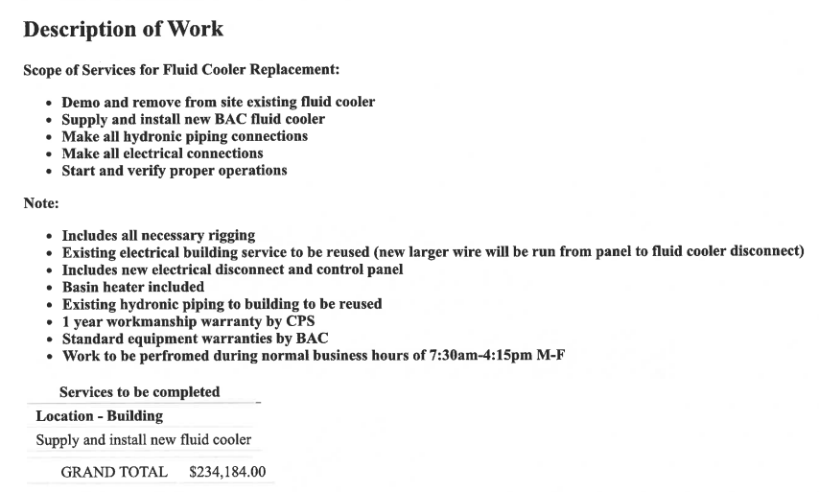

RECOMMENDATION

I recommend the Hardin County Board of Education approve the quote from comforT and process solutions for a cooling tower and boiler for old lt.

RECOMMENDED MOTION
I Move the Hardin County Board of Education approve the quote from comforT and process solutions for a cooling tower and bolier for old lt.

