THIS IS A DECISION PAPER

TO: HARDIN COUNTY BOARD OF EDUCATION

FROM: Teresa Morgan, Superintendent

DATE: December 21, 2023

SUBJECT: APPROVE BG 1 NHHS GREENHOUSE

ISSUE: The current NHHS greenhouse needs major repair

FACTS
The NHHS greenhouse needs repair.

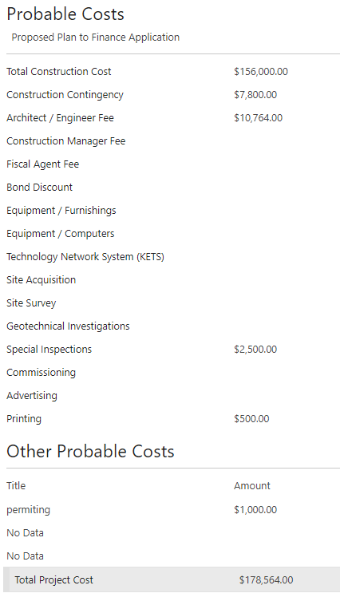

RECOMMENDATION
I RECOMMEND THE BOARD approve the BG 1 to renovate the NHHS GREENHOUSE.

RECOMMENDED MOTION

I MOVE THE BOARD approve the BG 1 to renovate the Nhhs greenhouse.

