THIS IS A DECISION PAPER

TO: HARDIN COUNTY BOARD OF EDUCATION

FROM: Teresa Morgan, Superintendent

DATE: December 21, 2023

SUBJECT: APPROVAL OF BG 5 FOR THE SITE ACQUISITION NEW WEST MIDDLE

ISSUE: The Board needs to approve BG 5 to close out the land acquisition for New West Hardin Middle.

FACTS:

We are ready to close this project and complete the necessary paperwork per KDE regulations. The BG 5 details all expenses for the purchase which totaled $ 507,919.

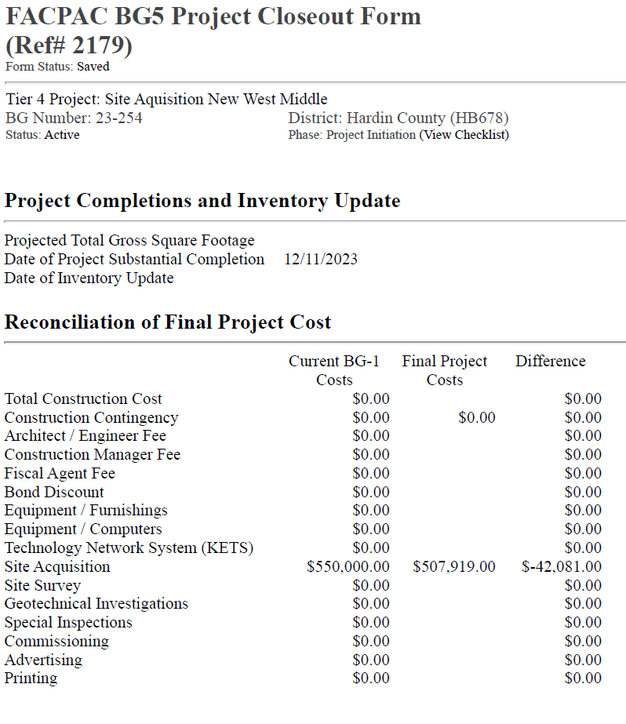

*See attached BG 5

RECOMMENDATION
I RECOMMEND THE BOARD APPROVE a BG 5 for site acquisition for the new west HARDIN middle.

RECOMMENDED MOTION

I MOVE THE BOARD APPROVE a Bg 5 for site acquisition for new west HARDIN middle.

