THIS IS A DECISION PAPER

TO: HARDIN COUNTY BOARD OF EDUCATION

FROM: Teresa Morgan, Superintendent

DATE: December 21, 2023

SUBJECT: APPROVAL OF CHANGE ORDERS 86-92 FOR THE CHHS PHASE 1 CONSTRUCTION PROJECT

ISSUE:
Change Orders 86-92 are debits of $ 8,012.95, $ 3,163, $ 4,799.31, $ 488.75, $ 2,526.30, $ 2,293.05, and $ 1,731.88 totaling $ 23,015.24. They are costs associated with additional fireproofing along the big gym wall, power and data for the cafeteria scoreboard, and drywall protection for sprinklers underneath the stairs in the big gym lobby.

FACTS:

CO 86

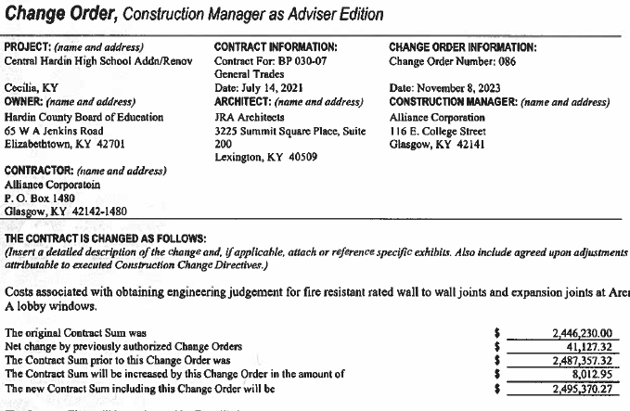

CO 87
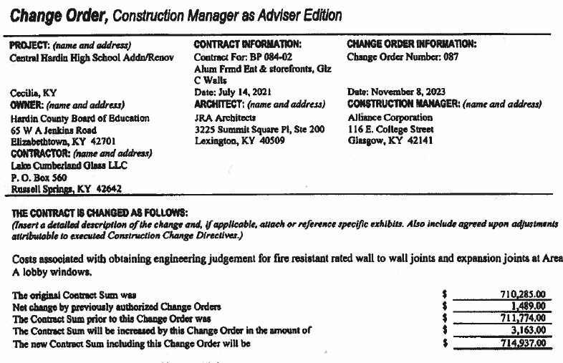
CO 88
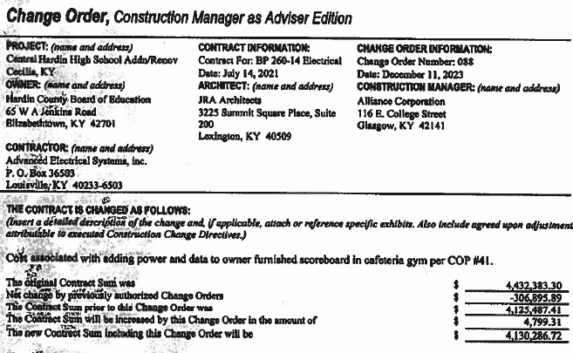

CO 89

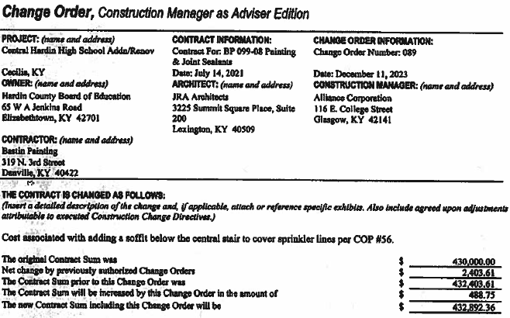

CO 90

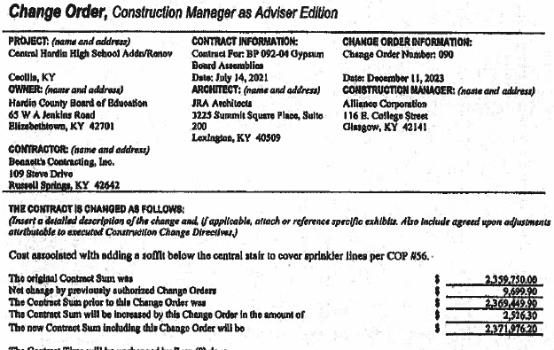

CO 91

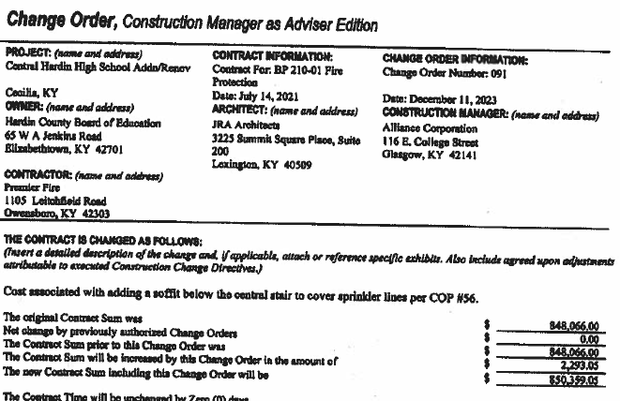

CO 92

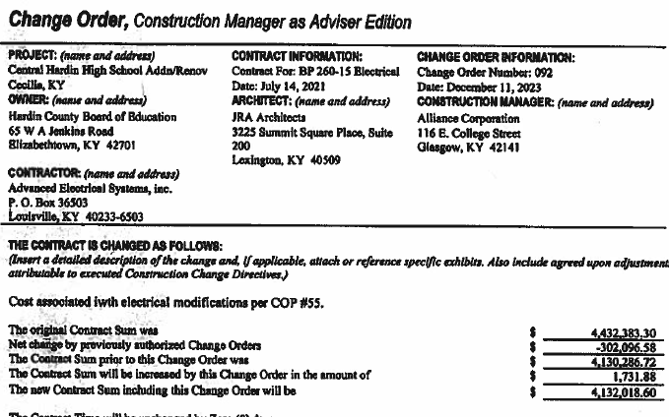

RECOMMENDATION
I RECOMMEND THE BOARD APPROVE CHANGE ORDERs 86-92 for the CHHS Phase 1 Construction project.

RECOMMENDED MOTION
I MOVE THE BOARD APPROVE CHANGE ORDERs 86-92 for the CHHS Phase 1 Construction project.

