THIS IS A DECISION PAPER

TO: HARDIN COUNTY BOARD OF EDUCATION

FROM: Teresa Morgan, Superintendent

DATE: November 16, 2023

SUBJECT: APPROVE BG 1 FOR HVAC/LIGHTING UPGRADES LAKEWOOD/NHE

ISSUE: KDE requires a BG 1 to begin a project.

FACTS

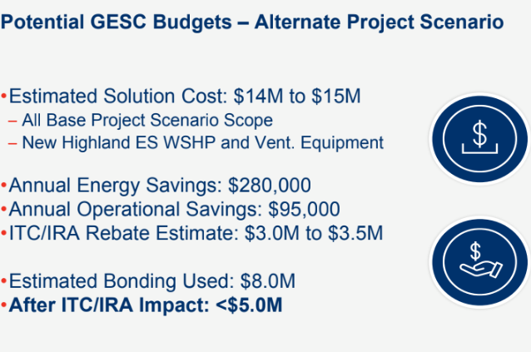

See attached BG 1

RECOMMENDATION
I RECOMMEND THE BOARD approve the bg1 for HVAC/LIGHTING UPGRADES LAKEWOOD/NHE.

RECOMMENDED MOTION

I MOVE THE BOARD approve the bG 1 for HVAC/LIGHTING UPGRADES LAKEWOOD/NHE.

