THIS IS A DECISION PAPER

TO: Hardin County Board Of Education Members

FROM: teresa morgan, Superintendent

DATE: November 16, 2023

SUBJECT: Reject Early Learning Academy Renovation bid

ISSUE

The Board needs to reject the bid per KDE regulations.

FACTS

Due to a reexamination of our Bid Policy, we had to rescind our offer to Bell Construction to complete the Early Learning Project. We subsequently rebid the project with a revised scope and got one bid back from T and T Construction.
Base Alt 1/6 Total
T and T $863,552 $91,297 $ 954,849

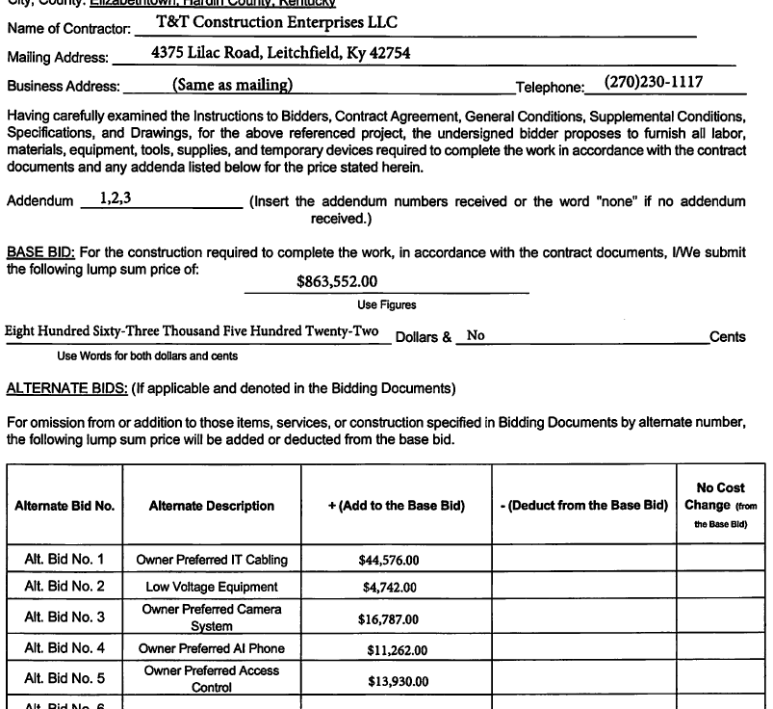

*See Attached Documents

RECOMMENDATION
I recommend the Hardin County Board of Education reject the bid from t & T construction and authorize John Stith to aggressively negotiate and or self-perform this project.

RECOMMENDED MOTION
I move the Hardin County Board of Education reject the bid from t & T construction and authorize John Stith to aggressively negotiate and or self-perform this project.

