THIS IS A DECISION PAPER

TO: HARDIN COUNTY BOARD OF EDUCATION

FROM: Teresa Morgan, Superintendent

DATE: November 16, 2023

SUBJECT: APPROVE BG 1 FOR SITE ACQUISITION FOR A NEW WEST HARDIN MIDDLE

ISSUE: KDE requires a BG 1 to further the site acquisition process.

FACTS

The Board has processed purchase agreements for acreage that adjoins its current property located in Cecilia, KY on the Cecilia Valley Campus site. This BG 1 will assist in getting the land deal approved by KDE.

Lush Property 31.375 acres $ 15,000 an acre $ 470,625
Buchanan Property 1.46 acres $ 25,000 an acre $ 36,525

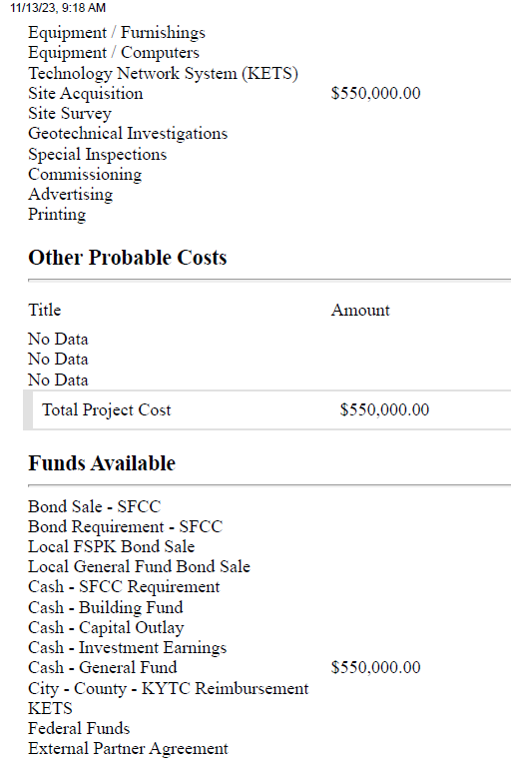

See attached BG 1

RECOMMENDATION
I RECOMMEND THE BOARD approve the bG1 for site acquisition for a new West hardin middle school.

RECOMMENDED MOTION

I MOVE THE BOARD approve the bG 1 for site acquisition for a new west hardin middle school.

