THIS IS A DECISION PAPER

TO: HARDIN COUNTY BOARD OF EDUCATION

FROM: Teresa Morgan, Superintendent

DATE: November 16, 2023

SUBJECT: APPROVAL OF BG 5 FOR THE CHHS DUGOUT REPAIR

ISSUE: The Board needs to approve BG 5 as the CHHS Dugout Repair is complete.

FACTS:

We are ready to close this project and complete the necessary paperwork per KDE regulations. The BG 5 details all expenses for the project which totaled $ 47,500.

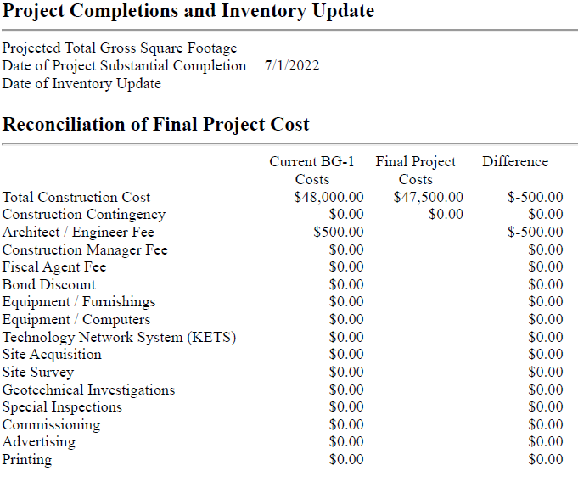

*See attached BG 5

RECOMMENDATION
I RECOMMEND THE BOARD APPROVE a BG 5 for the CHHS Dugout repair.

RECOMMENDED MOTION

I MOVE THE BOARD APPROVE a Bg 5 for the chhs dugout repair.

