THIS IS A DECISION PAPER

TO: HARDIN COUNTY BOARD OF EDUCATION

FROM: Teresa Morgan, Superintendent

DATE: November 16, 2023

SUBJECT: APPROVAL OF CHANGE ORDERS 84-85 FOR THE CHHS PHASE 1 CONSTRUCTION PROJECT

ISSUE:
Change Orders 84 and 85 are debits of $ 6,429 and $ 21,184.05. They are costs associated with remediating unsuitable soil.

FACTS:

CO 84

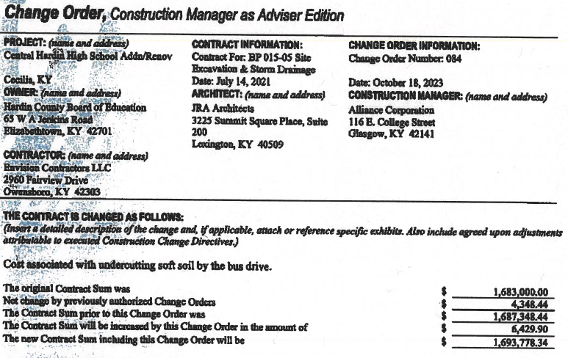

CO 85

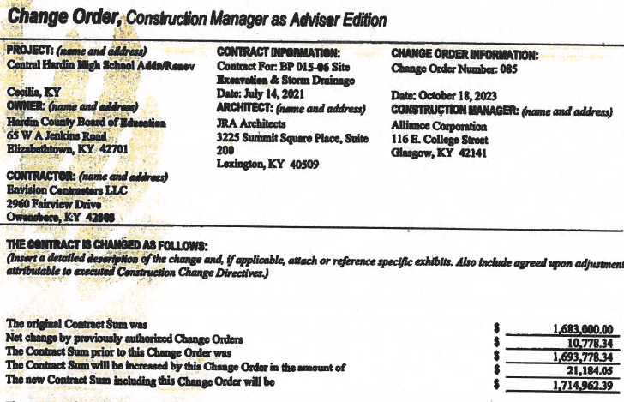

RECOMMENDATION
I RECOMMEND THE BOARD APPROVE CHANGE ORDERs 84 and 85 for the CHHS Phase 1 Construction project.

RECOMMENDED MOTION
I MOVE THE BOARD APPROVE CHANGE ORDERs 84 and 85 for the CHHS Phase 1 Construction project.

