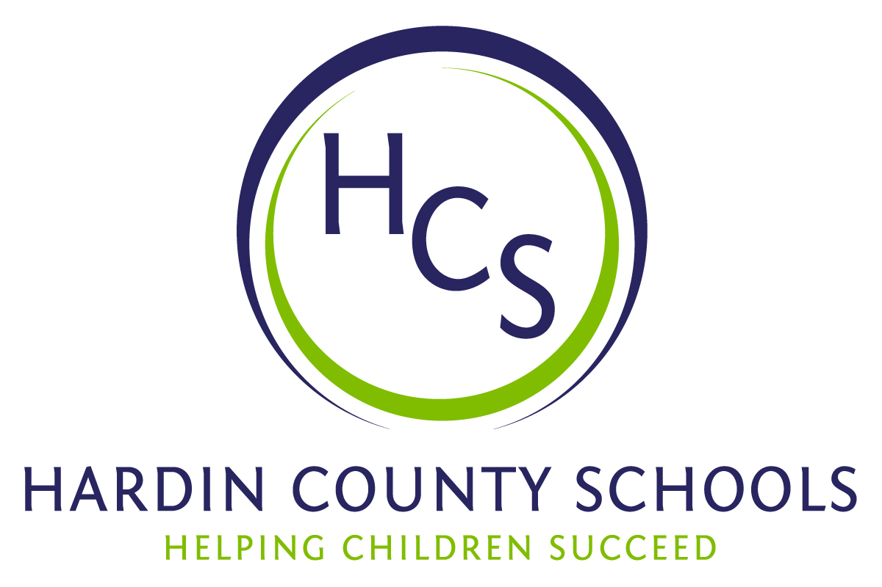
Board of Education
Dawn Johnson, Chair
Ben Sego, Vice Chair
Steve Bland
Mark Casey
Charlie Wise

Chief Academic Officer
Greg Sutton
Chief Operations Officer
John Stith

Teresa Morgan, Superintendent

Resolution of Recognition
#HCSBetterTogether Award

WHEREAS, the function of a Board of Education is to strive for excellence in all phases of educational programs, and;

WHEREAS, the Hardin County Board of Education deems it fitting and proper that significant awards and honors be recognized by the Board, and;

WHEREAS, the Hardin County Board of Education believes in work ethic and the ability of students, staff and community members who dedicate themselves totally to the education of our next generation of leaders, and;

WHEREAS, the district’s theme for the 2023-24 school year is #HCSBetterTogether and the Hardin County Board of Education believes in these characteristics so greatly that it will recognize HCS students & staff and Hardin County community members at its regularly scheduled meeting each month during the school year with the #HCSBetterTogether Award;

BE IT THEREFORE RESOLVED THAT the Hardin County Board of Education, in a regular meeting on November 16, 2023, does hereby recognize the following for earning the #HCSBetterTogether Award for November 2023:

- Laila Williams, a John Hardin High School junior, is captain of the girls track and cross-country team and vice president of marketing for the JHHS DECA club. She is raising money to promote mental health for her peers by selling candy grams and bracelets with positive notes. JHHS Principal Mark Wells says that Laila “has combined her strong work ethic and drive with her passion for helping others. Her project called ‘Athletes GAME (Giving Athletes Mental Empowerment)’ is designed to help athletes learn to balance the stress of being a student-athlete, something she has done very well. Layla has already introduced her project to JHHS students, and she is currently working on ideas for furthering her outreach.” She participates in “Boom Kentucky,” a program working with high school startups by merging coding and entrepreneurship. She will also participate in the Governor’s Scholars program next summer.

- Kandi Bradford is the Library Media Specialist and Sabrina Barney is an instructional assistant at Meadow View Elementary School. Ms. Bradford and Ms. Barney work with students in the school’s greenhouse each Friday. They spend the entire day in the greenhouse with classes from every grade level and supervise as students planted a number of vegetables and fruits last spring. Mrs. Bradford and Ms. Barney made it a priority to come to school this summer to water and tend the garden so students could enjoy a harvest when students returned to school. They have given the students a chance to harvest and eat various fruits and vegetables including honeydew melon. They even had students make zucchini bread and bake it in the school’s kitchen from zucchini grown by Meadow View students. The amount of time, energy, and resources that have been put into the greenhouse is immeasurable.

- Baptist Health Hardin, the Hardin County Coroner’s Office, Hardin County EMS, Elizabethtown Police Officer Larry Robinson, and Radcliff Police Officer Antonio Stephens have spent several days in our district’s high schools to present a drug overdose simulation. This work has taken them away from their full-time jobs but it has been critical to ensuring that our students know the dangers of drug abuse and the deadly habits it creates. The simulation is based on the fentanyl overdose death of Central Hardin High School graduate Andrew Mykytiuk. It's followed by a panel discussion among representatives of these agencies and a question and answer session with students.

These agencies and officers worked extremely hard to plan the simulations that have been presented several times at each of the district’s high schools. HCS is extremely grateful for the partnership it has with each of these agencies and its dedication to students.

