THIS IS A DECISION PAPER

TO: HARDIN COUNTY BOARD OF EDUCATION

FROM: Teresa Morgan, Superintendent

DATE: October 19, 2023

SUBJECT: APPROVAL OF TURF CHANGE ORDERS 1-2 AND SITE CHANGE ORDERS 5-7 FOR THE JHHS TURF PROJECT

ISSUE:
Site Change Orders 5-7 are credits of $ $ 2,753.16, $ 49.74, and $ 0. Turf Change Orders 1 and 2 are credits of $ 157.50 and $ 312.20. All change orders total $ 3,272.52 and are for used DPO amounts.

FACTS:

Site CO 5
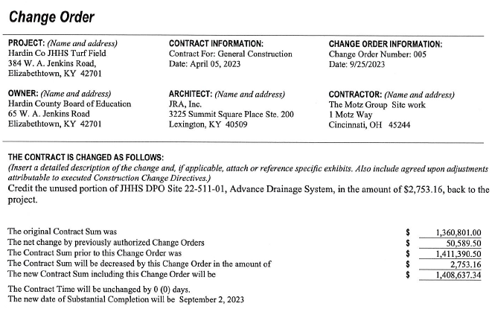

Site CO 6
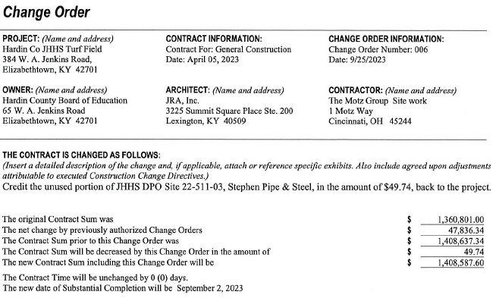

Site CO 7
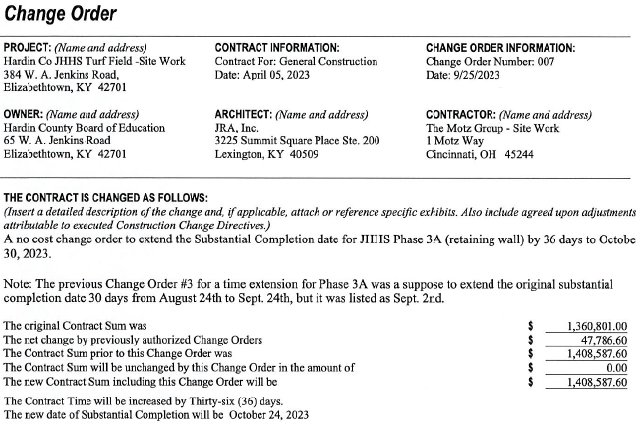

Turf CO 1

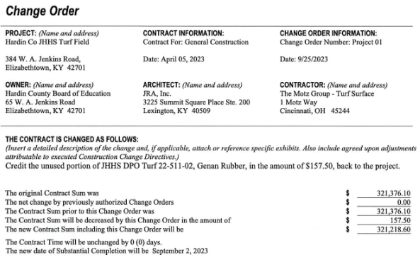

Turf CO 2

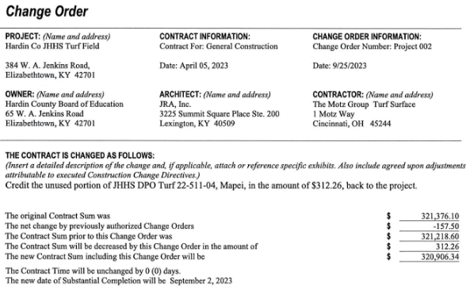

RECOMMENDATION
I RECOMMEND THE BOARD APPROVE SITE CHANGE ORDER 5-7 and Turf change Orders 1 and 2 for the JHHS turf project.

RECOMMENDED MOTION
I MOVE THE BOARD APPROVE SITE CHANGE ORDERs 5-7 and Turf change orders 1 and 2 for the JHHS Turf project.

