THIS IS A DECISION PAPER

TO: HARDIN COUNTY BOARD OF EDUCATION

FROM: Teresa Morgan, Superintendent

DATE: October 19, 2023

SUBJECT: APPROVAL OF SITE CHANGE ORDER 2 AND TURF CHANGE ORDERS 1 AND 2 FOR THE NHHS TURF PROJECT

ISSUE:
Site Change Order 2 is a credit of $ 2,849.5. Turf Change Orders 1 and 2 are credits of $ 43.50 and $ 313.6. Overall these credits total $ 3,206.65 and are for unused DPO amounts.

FACTS:

Site CO 2

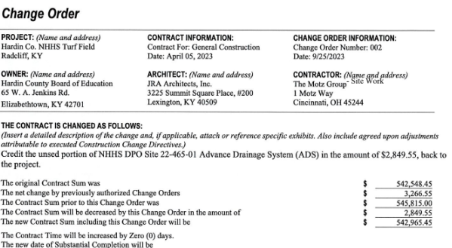

Turf CO 1

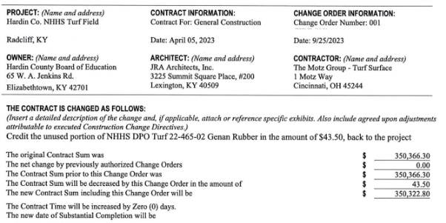

Turf CO 2

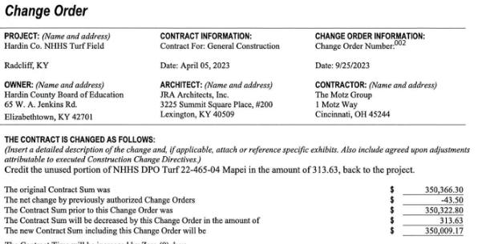

RECOMMENDATION
I RECOMMEND THE BOARD APPROVE Site CHANGE ORDER 1 and turf change orders 1 and 2 for the NHHS turf project.

RECOMMENDED MOTION
I MOVE THE BOARD APPROVE Site CHANGE ORDER 1 and turf change orders 1 and 2 for the NHHS Turf project.

