THIS IS A DECISION PAPER

TO: HARDIN COUNTY BOARD OF EDUCATION

FROM: Teresa Morgan, Superintendent

DATE: OCTOBER 19, 2023

SUBJECT: APPROVAL BG 4 FOR THE CHHS DUGOUT PROJECT

ISSUE:
Need to close out the CHHS dugout project.

FACTS:

KDE requires a BG 4 to close out a subcontractor's work.

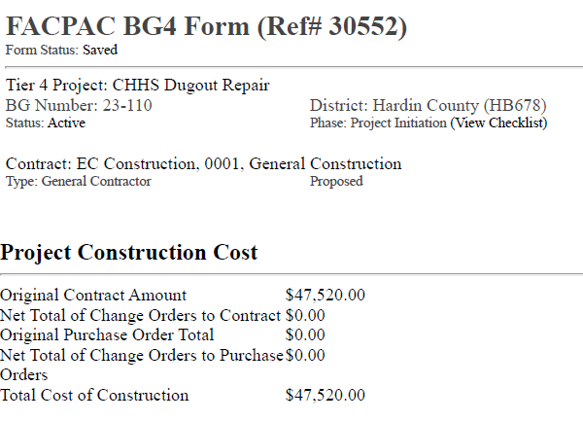

See attached BG 4

RECOMMENDATION
I RECOMMEND THE BOARD APPROVE the BG4 for the cHHS dugout project.

RECOMMENDED MOTION
I MOVE THE BOARD APPROVE the BG4 for the chhs dugout project.

