ENCLOSURE F-2
October 16, 2023
OLDHAM COUNTY BOARD OF EDUCATION
CONCERN
The district’s drug testing coordinator/data analyst is retiring November 30, 2023.
DISCUSSION
This position was initially created at 6 hours per day, 185 days per year, and paid on the 104 scale of the unified classified salary schedule.
With the growth of Infinite Campus use, data intake, drug testing services, and English Learners moving to the student services department, it is necessary to increase the position to 7.5 hours per day, 195 days per year. After completing an analysis of the position through a MAG survey, the position falls on the 105 scale of the unified salary scale for classified personnel.
RECOMMENDATION
Approve the revised contract for the Student Services’ Data Analyst position.

On a motion by _______________, seconded by _______________, the Board approved the revised contract for the Student Services’ Data Analyst position. ( , )

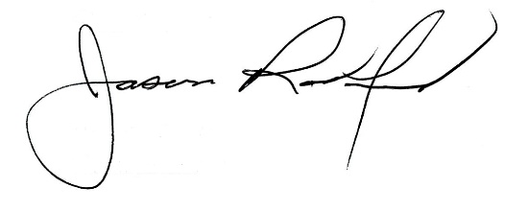
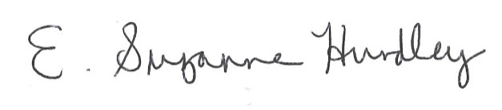

Suzanne Hundley, Board Chair Jason Radford, Superintendent/Secretary

