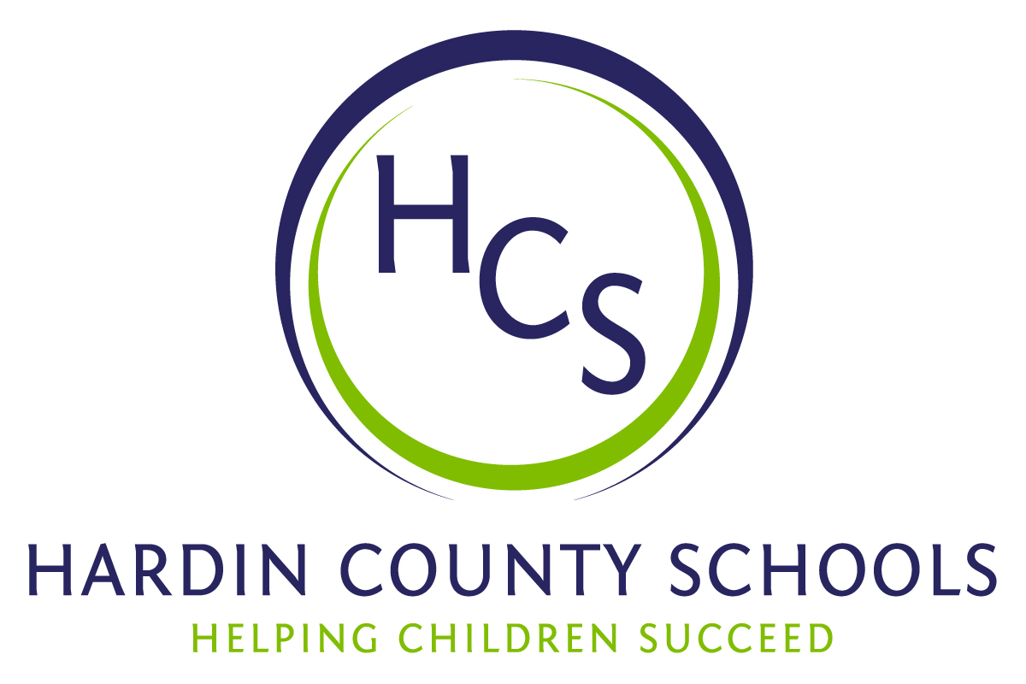
Board of Education
Dawn Johnson, Chair
Ben Sego, Vice Chair
Steve Bland
Mark Casey
Charlie Wise

Chief Academic Officer
Greg Sutton
Chief Operations Officer
John Stith

Teresa Morgan, Superintendent

Resolution of Recognition
#HCSBetterTogether Award

WHEREAS, the function of a Board of Education is to strive for excellence in all phases of educational programs, and;

WHEREAS, the Hardin County Board of Education deems it fitting and proper that significant awards and honors be recognized by the Board, and;

WHEREAS, the Hardin County Board of Education believes in work ethic and the ability of students, staff and community members who dedicate themselves totally to the education of our next generation of leaders, and;

WHEREAS, the district’s theme for the 2023-24 school year is #HCSBetterTogether and the Hardin County Board of Education believes in these characteristics so greatly that it will recognize HCS students & staff and Hardin County community members at its regularly scheduled meeting each month during the school year with the #HCSBetterTogether Award;

BE IT THEREFORE RESOLVED THAT the Hardin County Board of Education, in a regular meeting on October 19, 2023 does hereby recognize the following for earning the #HCSBetterTogether Award for October, 2023:

- Leia Reynolds, a North Hardin High School senior, is a very active student. She is part of the Hardin County Schools Culinary Arts Pathway located at the HCS Early College and Career Center. At the ripe age of 15, she became the lead baker for local restaurant Vibe Coffee. When she applied for a job there, it was for a barista position. Knowing that she had a passion for baking and that the coffee shop had a vacancy in that position, the owners quickly elevated her to lead baker. She has finished first and second in SkillsUSA competitions and has been part of state ProStart Invitational Culinary teams from EC3 that represented Kentucky at the National ProStart Competition. Leia also earned a blue ribbon at the Kentucky State Fair in the 4-H Cupcake Competition. She plans to further her culinary education at Sullivan University.

- Ally Trombley, a Radcliff Elementary School interventionist, is described by her principal Lisa Sturman as having the foundational characteristics of a teacher - passion, innovation and determination. She began her time at Radcliff teaching first grade. She quickly became the team leader and guided her team to new and innovative practices. Ally acknowledged academic deficits in her students and immediately determined effective interventions for her students for students in other first-grade classrooms. She was a natural choice for interventionist - a role in which she's demonstrated exceptional leadership. Mrs. Trombley has been instrumental in changing the way support systems are implemented at Radcliff Elementary. She has led efforts to inform, train and assist teachers as they put effective interventions in place. She continues to be an active committee member and mentors new teachers. Regardless of the task, Mrs. Trombley is consistently willing to lend her energy. Ms. Sturman emphasizes that she and her administrative team are honored to have her on staff and are proud to serve the students of Radcliff Elementary alongside her.

- Trinity Searcy and Kevin Addington, local business owners, have been critical in helping North Park Elementary School and new principal Laura Beth Hayes prepare for the school year. Mr. Searcy owns Karbec, an equipment solution firm, devoted some of his crew members to mow, trim and spread mulch. He also contacted Mr. Addington, owner of Addington Transportation, who brought equipment to move and spread mulch. They have no ties to the school other than just hearing Mrs. Hayes a need. Mr. Searcy surprised Mrs. Hayes by initiating the work.

