THIS IS A DECISION PAPER

TO: Hardin County Board Of Education Members

FROM: Teresa Morgan, Superintendent

DATE: October 5, 2023

SUBJECT: approve CPS Cooling Tower quote for Old LTes

ISSUE:

The current cooling tower at the old Lincoln Trail is past its useful life and is in need of replacement to ensure the facility has adequate cooling capacity. Due to the 3-4 month lead time, it would be prudent to address this issue now to avoid having the current tower down for a prolonged period of time.

FACTS:

All are the same tower (BAC) and have a 14-16 week lead time.

CPS- $234,184
Knights- $269,740
Schardein- $275,390

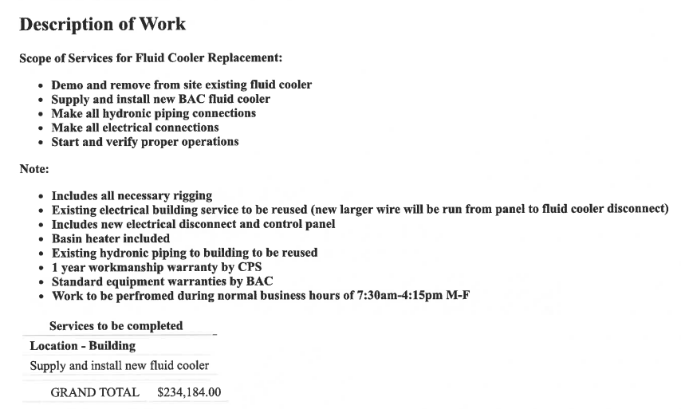

RECOMMENDATION

I recommend the Hardin County Board of Education approve the quote from comforT and process solutions for a cooling tower for old ltES.

RECOMMENDED MOTION
I Move the Hardin County Board of Education approve the quote from comfort and process solutions for a cooling tower for old ltES.

