CONSENT ITEM A
September 25, 2023
OLDHAM COUNTY BOARD OF EDUCATION
CONCERN
Consider Approval of Field Trips Requesting Overnight Stay & Field Trips Requesting Use of Common Carrier.
DISCUSSION
The following are field trips requesting overnight stay and trips requesting use of a common carrier:
SCHOOL | GROUP | LOCATION/DATE | JUSTIFICATION | INSTR. DAYS LOST
SOHS | FCCLA | Birmingham, AL  November 9-12, 2021 | Overnight: FCCLA National Conference  Jefferson Tours | 2
OCHS | Forensic Science | Frankfort, KY  December 15, 2023 | Overnight: Class Enrichment  Miller Transport | 1
OCHS | Dance Team | Orlando, FL  March 6-11, 2024 | Overnight: Nationals  Flying | 4
OCHS | Dance Team | Indiana  December 2-3,2023 | Overnight: Regionals  Parent Transport | 0
OCHS | KUNA | Marriott Hotel  March 24-26, 2024 | Overnight: KUNA Conference  Parent Transport | 2
OCHS | KYA | Crown Plaza  Dec 10-12, 2023 | Overnight: KYA Conference  Parent Transport | 2
SOMS | Choir | Louisville, KY  Feb 21-24, 2024 | Overnight: ACDA Conference  Miller Transportation
SOMS | Choir | EKU  Nov 10-11, 2023 | Overnight: KYACDA Honor Choir  Parent Transport
SOMS | Choir | Galt House, Louisville  Feb 7-8,2024 | Overnight: KMEA Honor Choir  Parent Transport
RECOMMENDATION
Approve the field trips as attached and described above, pursuant to the condition that students not traveling on school buses, with their parents, or with a Board employee whose insurance carrier has named OCBE as an additional named insured, will be transported to and from their destination on an approved charter bus(es) and school(s) shall obtain written evidence of liability.

On a motion by _______________, seconded by _______________, the Board approved the field trips as attached and described above, pursuant to the condition that students not traveling on school buses, with their parents, or with a Board employee whose insurance carrier has named OCBE as an additional named insured, will be transported to and from their destination on an approved charter bus(es) and school(s) shall obtain written evidence of liability. ( , )

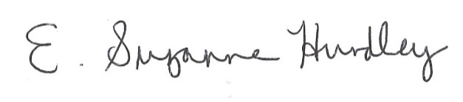
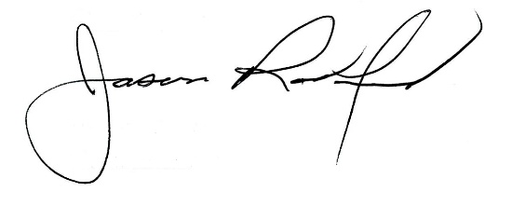

Suzanne Hundley, Board Chair Jason Radford, Superintendent/Secretary

