ACTION ITEM A
September 25, 2023
OLDHAM COUNTY BOARD OF EDUCATION
CONCERN
Consider approval of the Working Budget for the year ending June 30, 2024 (FY24)
DISCUSSION
The Oldham County Board of Education FY24 working budget includes estimated revenues and expenditures for all required funds. This working budget was prepared based on the following assumptions, among others:
- State funding of $43,634,893 consisting of:
    - General Fund SEEK $37,278,651
    - Capital Outlay 1,151,098
Plus State nickel equalization for:
    - Building Fund 5,205.144

These amounts are based on final property assessments and FY22-23 AADA. Changes to FY24 SEEK include an increase of $100 in the per-student guaranteed base.
- Real/Personal/PSC Property Tax gross revenue of $66,753,049 based on PVA property tax based assessed values of $9,092,588,181 at 81.2 cents per $100 of assessed value. Those taxes will be allocated between funds as follows:
    - General Fund $48,567,873
    - Building Fund 18,185,176
- FY24 expenditures are based on FY23 levels adjusted for planned increases that include:
    - Wage increases for step changes and step-related benefits and a 2% merit increase for all employees.
    - Overall inflation (diesel fuel, utilities, travel)
- Special Revenue (Fund 2 Grants) amounts will require additional adjustment per approved Federal / State awards and estimates, which will be available in early Fall.
Budgeted expenditures for FY24 include a General Fund contingency of $16.0 million. Of this amount, $2.4 million is reserved for one-time stipends for all employees previously approved by the Board.
As the District progresses through FY24, budgeted revenues and expenditures will be monitored, and any significant amendments will be made.
RECOMMENDATION
Approve the FY24 working budget for submission to KDE.

On a motion by _______________, seconded by _______________, the Board approved the FY24 working budget for submission to KDE. ( , )

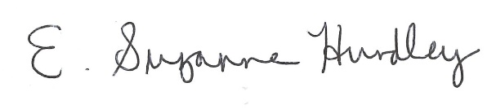
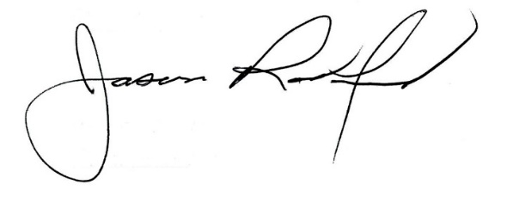

Suzanne Hundley, Board Chair Jason Radford, Superintendent/Secretary

