CONSENT ITEM H
September 25, 2023
OLDHAM COUNTY BOARD OF EDUCATION
CONCERN
Consider Shortened School Day request for OCS students.
DISCUSSION
The following students have requested a Shortened School Day. Details for each student follow this enclosure for your review.
STUDENT | SCHOOL
A.M. | EOMS
J.L. | NOMS
M.H. | CR
S.N. | NOMS
W.S. | OCHS

RECOMMENDATION
Post-approve the shortened school day request for these students.

On a motion by _______________, seconded by _______________, the Board post approved the Shortened School Day requests as submitted. ( , )

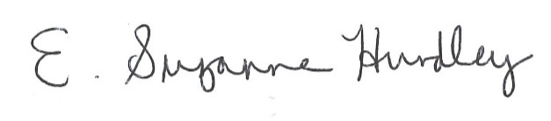
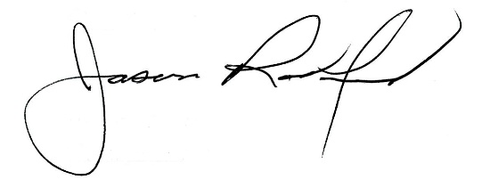

Suzanne Hundley, Board Chair Jason Radford, Superintendent/Secretary

