ENCLOSURE F
September 25, 2023
OLDHAM COUNTY BOARD OF EDUCATION
CONSIDER
Consider approval of an amended FY24 Student Athletic Insurance to include additional coverage for all students during all school sponsored and sanctioned activities including the school day.
DISCUSSION
Each year, the district is required to purchase (and has purchased) student athletic insurance to cover liability up to the KHSAA catastrophic injury insurance coverage. In addition, each year the district offers individual student insurance at a minimal cost for students without insurance, or for those who wish to have supplemental coverage.
For the remainder of FY24 school year, Roberts Insurance has submitted a quote to increase our coverage from the current level 4 plan for student athletes only to their level 3 plan for all students in the district during the entire school day along with all school sponsored athletic and or other sanctioned events our students attend. The carrier will continue to be Zurich Insurance.
Current athletic plan only at a level 4 cost $21,300.
To increase to athletic plan level 3 would cost an additional $6,475.
To increase to all students for the entire school day as well as all athletic, school sponsored and or sanctioned events would cost an additional $24,001.
Total cost would be $45,301 and we have already spent $21,300 - approved May or 2023.
Based on the information provided, we are recommending that the Board increase the contract with Roberts Insurance to a level 3 plan that covers all students’ insurance.
RECOMMENDATION
Approve the additional supplemental insurance coverage to cover all students with Roberts Insurance, for a cost of an additional $24,001.

On a motion by _______________, seconded by _______________, the Board approved the purchase of additional supplemental insurance to cover all students with Roberts Insurance, for a cost of an additional $24,001.

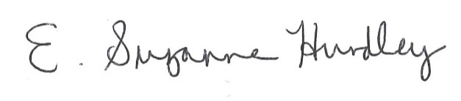
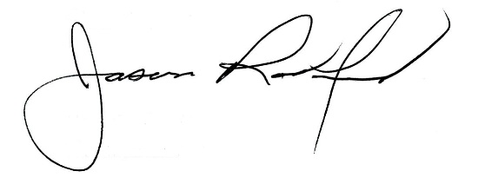

Suzanne Hundley, Board Chair Jason Radford, Superintendent/Secretary

