OLDHAM COUNTY BOARD OF EDUCATION
SPECIAL-CALLED MEETING MINUTES
August 31, 2023
Board Administrative Office
6165 W HWY 146
Crestwood, KY 40014
Conference Room

The Oldham County Board of Education met in a special-called session at the Board’s administrative office in Crestwood, Kentucky on Thursday, August 31, 20231. The following members were present (1) Suzanne Hundley, Board Chair; (2) Joe Dennis, Board Member; (3) Carly Clem, Board Member; and Allison Sheffer, Board Member. Dr. Jason Radford, Superintendent/Secretary to the Board, Eric Farris, General Counsel, Eric Davis, Director of Student Services and South Oldham High School Principal Melissa Woosley, were also present.
- MEETING CALLED TO ORDER
Chair Suzanne Hundley called the meeting to order at 4:47 p.m.
- AGENDA APPROVAL
Chair Hundley called for a motion to approve the agenda. On a motion by Allison Sheffer, seconded by Carly Clem, the Board approved the August 31, 2023, special-called meeting agenda (4-0).
- EXECUTIVE SESSION
Eric Farris advised the board that prior to the hearing, the parent and student had waived their right to a hearing. Eric Farris recommended that the board accept the recommendation from the expulsion committee and accept the placement.
On a motion by Allison Sheffer, seconded by Carly Clem, the Board accepted the expulsion committee recommendation to accept the placement. (4,0)
The board did not go into executive session.
- ADJOURN
With no further business to discuss, on a recommendation from the Superintendent, Chair Hundley called for a motion and a second to adjourn. On motion by Carly Clem, seconded by Joe Dennis the Board adjourned the August 31, 2023, special called meeting at 4:51 p.m. (4-0).

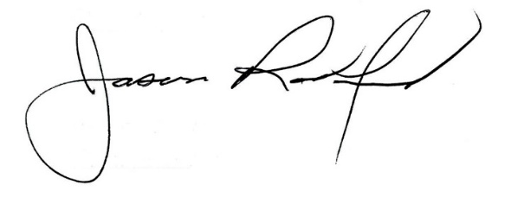
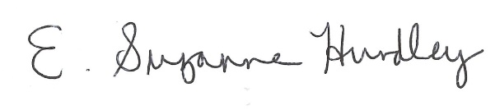

Suzanne Hundley, Board Chairperson Jason Radford, Ed. S, Superintendent/Secretary

