OLDHAM COUNTY BOARD OF EDUCATION
Special Called TAX Hearing
August 28, 2023 4:00 PM
ARVIN EDUCATION CENTER
1650 Colonels Drive, La Grange, KY 40031
Attendance Taken at: 4:00 PM
Present Board Members:
Mrs. Suzanne Hundley
Mr. Larry Dodson
Mr. Joe Dennis
Ms. Allison Sheffer

Updated Attendance:
Ms. Carly Clem was updated to present at: 4:06 PM

- CALL MEETING TO ORDER
Chair Hundley called the meeting to order at 4 pm.

- APPROVE AGENDA
Motion Passed: Approval of the agenda passed with a motion by Ms. Allison Sheffer and a second by Mr. Larry Dodson. 4 Yeas - 0 Nays
- SUPERINTENDENT REPORT
Dr. Tom Shelton, Interim CFO presented a review of FY24 Tax Information.
- PUBLIC EXPRESSION
Chairperson Hundley stated it was time for public expression and called upon the public expression registrar Michael Williams for the registered speakers. 3 people had registered to speak. Chairperson Hundley proceeded with public expression and the board decided to allow each speaker 5 minutes to address their concerns to the board: Albert Harrison., Linda Stasiowski, Elain Carroll presented their concerns to the board.
- ADJOURN
Chairperson Hundley, acting on the Superintendent's recommendation to adjourn, called for a motion and a second to adjourn.
Motion Passed: Approval to adjourn at 4:23 pm passed with a motion by Ms. Allison Sheffer and a second by Ms. Carly Clem. 5 Yeas - 0 Nays

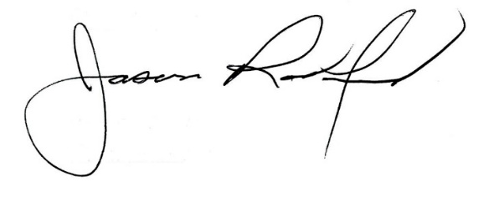
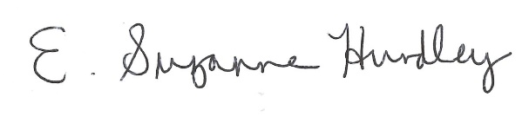

Suzanne Hundley, Board Chairperson Jason Radford, Ed. S, Superintendent/Secretary

