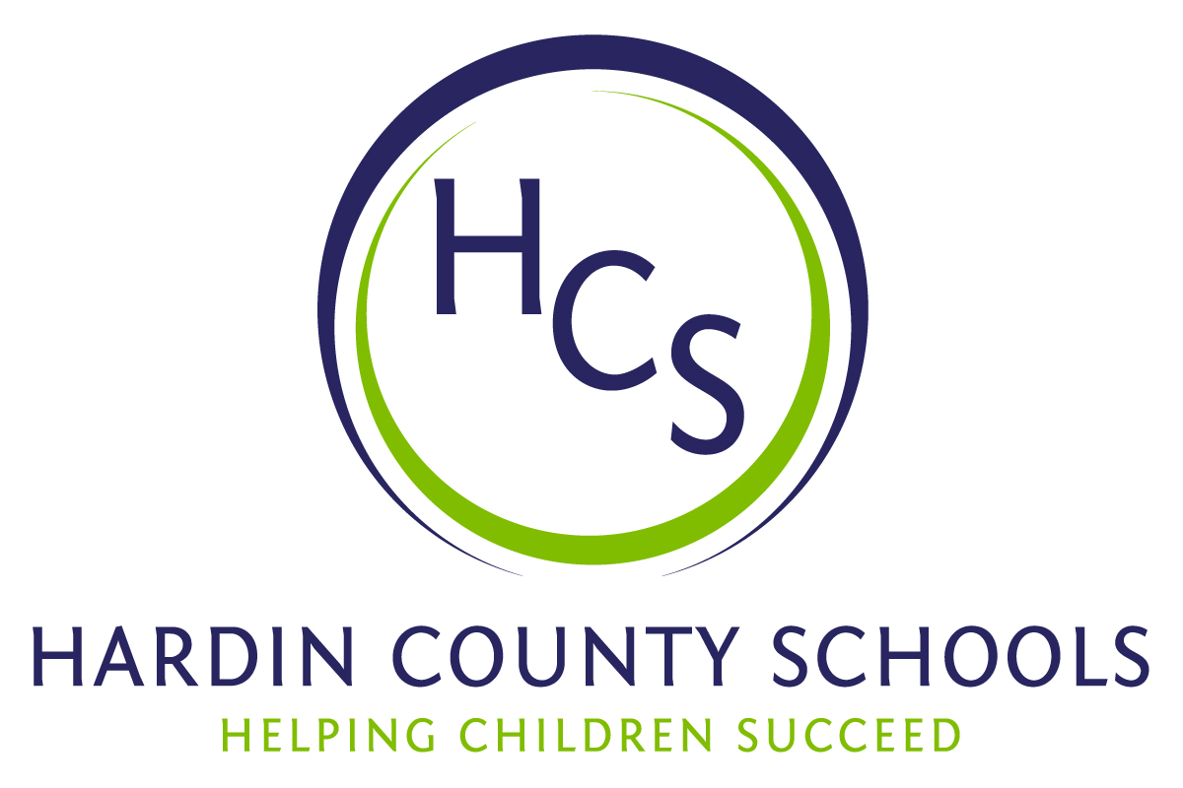
Board of Education
Dawn Johnson, Chair
Ben Sego, Vice Chair
Steve Bland
Mark Casey
Charlie Wise

Chief Academic Officer
Greg Sutton
Chief Operations Officer
John Stith

Teresa Morgan, Superintendent

Resolution of Recognition
#HCSBetterTogether Award

WHEREAS, the function of a Board of Education is to strive for excellence in all phases of educational programs, and;

WHEREAS, the Hardin County Board of Education deems it fitting and proper that significant awards and honors be recognized by the Board, and;

WHEREAS, the Hardin County Board of Education believes in work ethic and the ability of students, staff, and community members who dedicate themselves totally to the education of our next generation of leaders, and;

WHEREAS, the district’s theme for the 2023-24 school year is #HCSBetterTogether and the Hardin County Board of Education believes in these characteristics so greatly that it will recognize HCS students & staff and Hardin County community members at its regularly scheduled meeting each month during the school year with the #HCSBetterTogether Award;

BE IT THEREFORE RESOLVED THAT the Hardin County Board of Education, in a regular meeting on September 21, 2023, does hereby recognize the following for earning the #HCSBetterTogether Award for September 2023:

- Chloe Frye, a Central Hardin High School senior, was part of an extremely special project. The Make a Wish Foundation contacted Jones Home Center with a special request to help in building a young lady’s dream playhouse with a two-week turnaround time. Chloe is a co-op student at Jones Home Center. Her work was critical to the project. She helped order materials, assisted in the design process, and was in charge of putting the furnishings for the playhouse together. Chloe, members of the Campbellsville University Bass Fishing team that includes a CHHS alum and many others made a very special young lady’s dreams come true.

- Chris Lawrence, a custodian at Woodland Elementary School, is worthy of this month’s #HCSBetterTogether Award because of her dedication to task and passion for students. Because Chris knows the Woodland Elementary School inside and out, she noticed something that just didn’t look right while changing HVAC unit filters in the building’s attic. She noticed that some trusses had been cut where they shouldn’t have been while crews were completing HVAC work. She immediately contacted the proper HCS staff members who reached out to our friends at ICON Engineering. Chris’ quick action started immediate work to correct a major problem that could have had terrible results.

- Major Chris Streck has worked feverishly to make the Salvation Army a hub of resources for families and people in need. He has invested his energies in the following projects. He has become an integral part of the community working with HCS Family Resource and Youth Service Centers, United Way, Helping Hand of Hope, and Community Action. His work has assisted thousands of children and families with holiday assistance by working with organizations, agencies, churches, and Hardin County Schools. He is committed to the betterment of Hardin County and the individuals and families that he serves.

- Trinity Searcy and Kevin Addington, local business owners, have been critical in helping North Park Elementary School and new principal Laura Beth Hayes prepare for the school year. Mr. Searcy owns Karbec, an equipment solution firm, and devoted some of his crew members to mow, trim, and spread mulch. He also contacted Mr. Addington, owner of Addington Transportation, who brought equipment to move and spread mulch. They have no ties to the school other than just hearing Mrs. Hayes had a need. Mr. Searcy surprised Mrs. Hayes by initiating the work.

