THIS IS A DECISION PAPER

TO: HARDIN COUNTY BOARD OF EDUCATION

FROM: Teresa Morgan, Superintendent

DATE: SEPTEMBER 21, 2023

SUBJECT: APPROVAL OF CHANGE ORDERS 80-83 FOR THE CHHS PHASE 1 CONSTRUCTION PROJECT

ISSUE:
Change Orders 80, 81, 82 are debits of 20,994.77, $ 1,489, and $ 5,357.13. They are costs associated with the fire-rated windows in the big gym and electrical work for the site lighting. Change Order 83 is a credit of $ 2,678.56 and is for site lighting.

FACTS:

CO 80
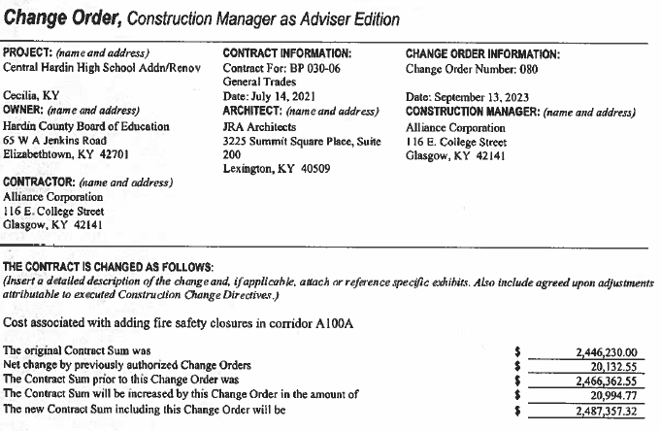

CO 81
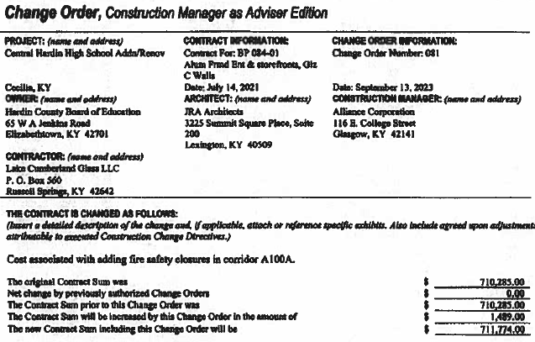

CO 82

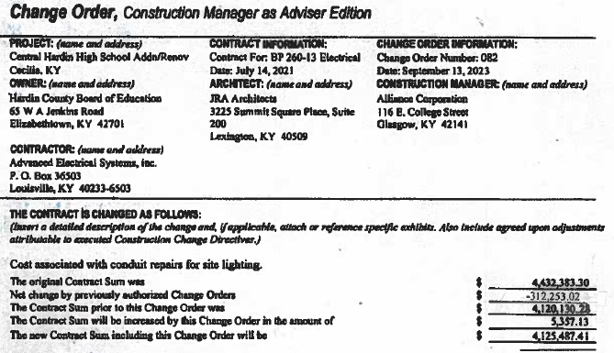

CO 83
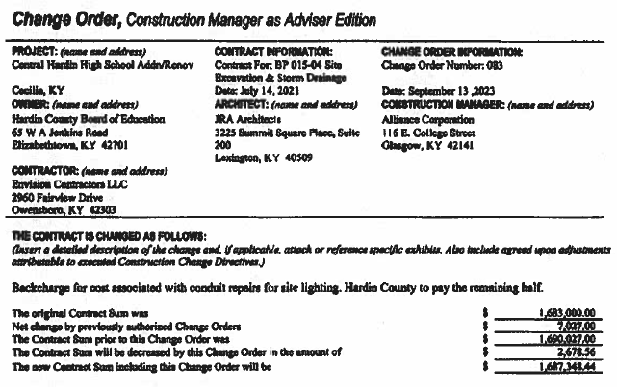

RECOMMENDATION
I RECOMMEND THE BOARD APPROVE CHANGE ORDERs 80-83 for the CHHS Phase 1 Construction project.

RECOMMENDED MOTION
I MOVE THE BOARD APPROVE CHANGE ORDERs 80-83 for the CHHS Phase 1 Construction project.

