THIS IS A DECISION PAPER

TO: HARDIN COUNTY BOARD OF EDUCATION

FROM: Teresa Morgan, Superintendent

DATE: SEPTEMBER 21, 2023

SUBJECT: APPROVAL OF BG 5 FOR THE EC3 LAND PURCHASE

ISSUE: The Board needs to approve BG 5 as the ECTC/EC3 land deal is complete.

FACTS:

We are ready to close this project and complete the necessary paperwork per KDE regulations. The BG 5 details all expenses for the project which totaled $ 100,000.

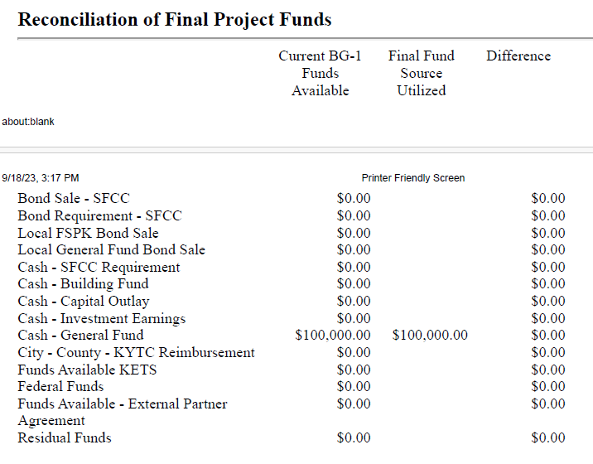

*See Attached Munis Report

RECOMMENDATION
I RECOMMEND THE BOARD APPROVE BG 5 for the ECTC/EC3 land purchase.

RECOMMENDED MOTION

I MOVE THE BOARD APPROVE Bg 5 for the ECTC/EC3 land purchase.

