THIS IS A DECISION PAPER

TO: HARDIN COUNTY BOARD OF EDUCATION

FROM: Teresa Morgan, Superintendent

DATE: SEPTEMBER 21, 2023

SUBJECT: APPROVAL OF CHANGE ORDER 4 FOR THE JHHS TURF PROJECT

ISSUE:
Change Order 4 is a debit of $ 6,500 and is for the installation of a 4-inch perforated pipe 385 ft. long to allow water to drain.

FACTS:

CO 4

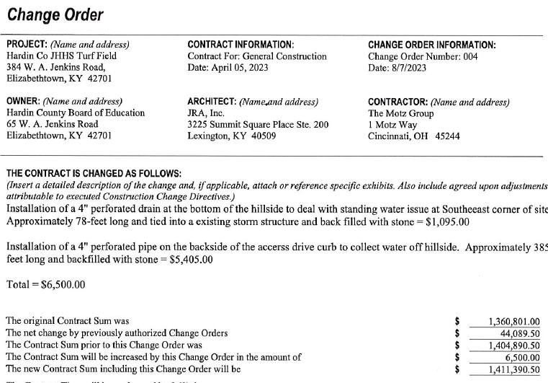

RECOMMENDATION
I RECOMMEND THE BOARD APPROVE CHANGE ORDER 4 for the JHHS turf project.

RECOMMENDED MOTION
I MOVE THE BOARD APPROVE CHANGE ORDER 4 for the JHHS Turf project.

