THIS IS A DECISION PAPER

TO: HARDIN COUNTY BOARD OF EDUCATION

FROM: Teresa Morgan, Superintendent

DATE: SEPTEMBER 21, 2023

SUBJECT: APPROVAL OF CHANGE ORDER 1 FOR THE NHHS TURF PROJECT

ISSUE:
Change Order 1 is a debit of $ 3,266.55 and is for unsuitable soil remediation.

FACTS:

CO 1
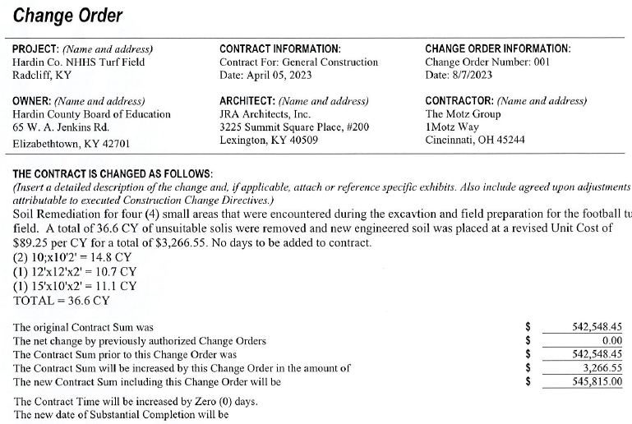

RECOMMENDATION
I RECOMMEND THE BOARD APPROVE CHANGE ORDER 1 for the NHHS turf project.

RECOMMENDED MOTION
I MOVE THE BOARD APPROVE CHANGE ORDER 1 for the NHHS Turf project.

