EXECUTIVE SESSION
July 31, 2023
OLDHAM COUNTY BOARD OF EDUCATION
CONCERN
Consider Executive Session pursuant to KRS 61.810(1)(c) to discuss litigation preparation, the public disclosure of which would jeopardize the Board’s position and KRS 61.810(1)(k) and KRS 156.557(6)(c) for preliminary discussions related to the evaluation of the Superintendent by the Board.
DISCUSSION
At this time, I need a motion to go into Executive Session pursuant to KRS 61.810(1)(c) to discuss litigation preparation, the public disclosure of which would jeopardize the Board’s position and KRS 61.810(1)(k) and KRS 156.557(6)(c) for preliminary discussions related to the evaluation of the Superintendent by the Board.
RECOMMENDATION
Conduct Executive Session.

On a motion by _______________, seconded by _______________, the Board entered into Executive Session pursuant to KRS 61.810(1)(c) to discuss litigation preparation, the public disclosure of which would jeopardize the Board’s position and KRS 61.810(1)(k) and KRS 156.557(6)(c) for preliminary discussions related to the evaluation of the Superintendent by the Board. (_,_)

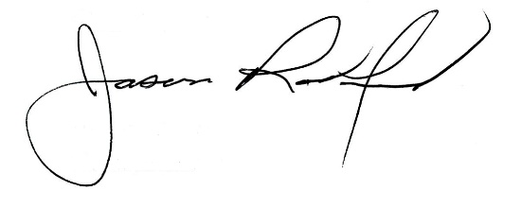
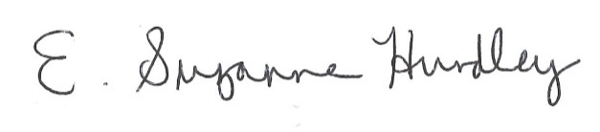

Suzanne Hundley, Board Chair Jason Radford, Superintendent/Secretary

