ACTION ITEM A
JULY 31, 2023
OLDHAM COUNTY BOARD OF EDUCATION
CONCERN
Consider approval of the Unaudited Annual Financial Reports (UAFR) for FY23.
DISCUSSION
The unaudited FY23 UAFR reports are attached for your review.
The following is a summary of some significant results reported within the Unaudited AFR.
- General Fund balance at 6/30/2023 is $24,360,321.
Variance Analysis:
Actual Budget
 | FY23 | FY23 | Variance
Revenues | $100,646,920 | $98,082,498 | $2,564,422 | 2.6%
Expenses | 94,552,904 | 100,160,948 | 5,608,044 | 5.6%
Comments:
FY23 revenues and expenses are adjusted in the above variance analysis schedule to exclude on-behalf revenues and expenditures.
After adjusting the beginning fund balance based on the FY22 audit, our contingency balance is $16,027,324 or 16%.
Other Significant District Fund Balances:
  - Activity Fund Balances $ 1,162,869
  - Capital Outlay Fund Balance 2,788,171
  - Building Fund Balance 16,012,655
  - Construction Fund Balance 17,172,818
  - Food Service Net Assets 4,419,161
  - Daycare Net Assets 4,513,191
RECOMMENDATION
Approve the FY23 Unaudited Annual Financial Report and direct the Superintendent to continue analyzing and revising as additional information becomes available (accounts receivable and/or payable, fixed assets, etc.), or as required by KDE to finalize transactions in preparation for the annual financial statement audit.

On a motion by _______________, seconded by _______________, the Board approved the FY23 Unaudited Annual Financial Report and directs the Superintendent to continue analyzing and revising as additional information becomes available (accounts receivable and/or payable, fixed assets, etc.), or as required by KDE to finalize transactions in preparation for the annual financial statement audit.. ( , )
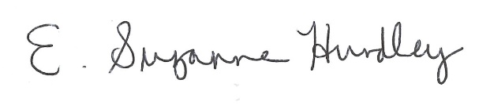
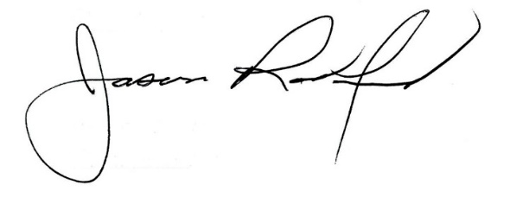

Suzanne Hundley, Board Chair Jason Radford, Superintendent/Secretary

