OCS Construction Report
  - July 2023

OCHS Foundation Repairs & Roof Project Ph. 3 (Remaining Bldg. 1 – Roof Replacement Gym and Auditorium
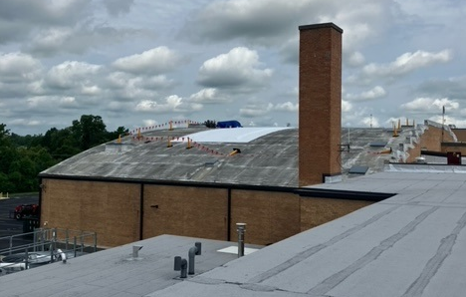
Conditional Approval for construction received, Roof tear-off and temp roof installation ongoing.
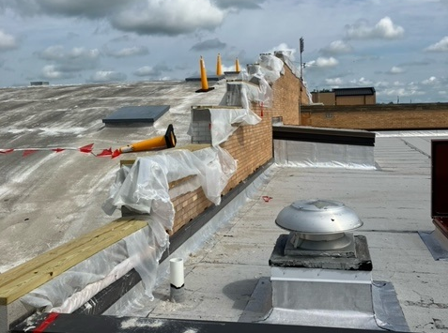
Construction schedule:

Construction commencement | Weather permitting gym access will be restored prior to the first day of school
Substantial Completion | January 2024

SOHS Phase II – Fieldhouse Renovation & Site Improvements
Project closeout in progress.
BG-4 submitted for approval tonight.

SOHS Major Renovation Phase 3 – Fire Alarm Upgrades
Project nearing completion – working with ADT to tie into monitoring system.
Pre-punch is in progress.

East Oldham M.S. Classroom Addition and Roof Replacement
Project closeout in progress.
BG-1 Project Reconciliation | August 2023

Athletic Stadium and Field Improvements at Various Schools Bid Package A (SOHS Field Lighting), Bid Package B (SOHS Concession Stand / SOHS & OCHS Stadium Upgrades), and Bid Package C (Turf Replacement OCHS & NOHS)
SOHS Field Lighting (Bid Package A):
Lights have been installed and are operational.
Closeout in process.
BG-4 | August 2023
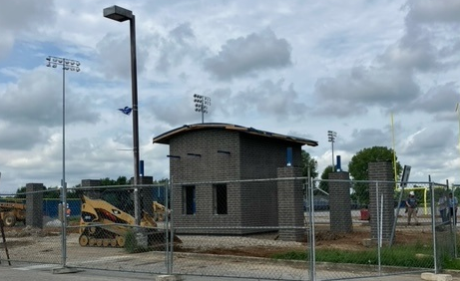
SOHS Concession Stand / SOHS & OCHS Stadium Upgrades:
SOSH Concession Stand & Ticket Booth & Track Improvements / OCHS Ticket Booth & Track Improvements (Bid Package B):
OCHS
OCHS Ticket Booth:
Footing and foundations complete, electrical rough-ins complete.
CMU and Brickwork complete, Roof structure installed, masonry columns complete.
Metal canopy installed.
SOHS Concession Stand:
Rock removal complete, concrete foundation walls complete, steel is on site
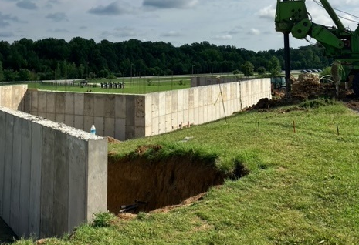
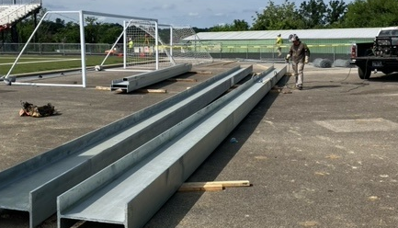

SOHS Scoreboard:
Foundations drilling underway.
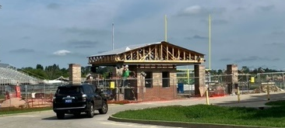
SOHS Ticket Booth:
CMU complete; brickwork complete, roof trusses installed.

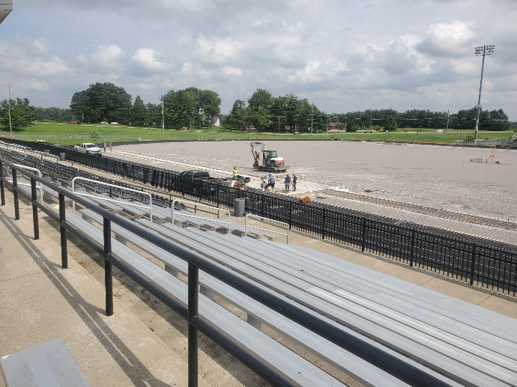
Turf Replacement at NOHS & OCHS (Bid Package C)
NOHS Turf Replacement:
Grass turf removal complete.
Grading of fields is complete.
Subgrade drainage complete.
Top rock installed.
Field event pits and runway nearing completion.

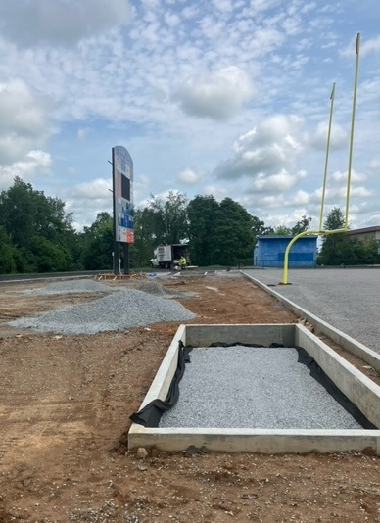
OCHS Turf Replacement:
Drainage complete, final grading complete, gravel sub-surface complete, sideline fencing complete, concrete curbs at jump-pits complete. Turf installation started.

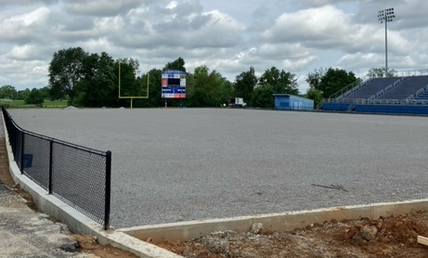

Schedule for Bid Packages A, B, & C

Substantial Completion | SOHS | Field Lighting |  | April 2023
Substantial Completion | OCHS | Turf Replacement |  | July 16, 2023 (MFG Delay)
Substantial Completion | SOHS | Ticket Booth & Scoreboard |  | July 31, 2023 (Expected Delay)
Substantial Completion | OCHS | New Ticket Booth & Entry Plaza |  | July 31, 2023 (Expected Delay)
Substantial Completion | NOHS | Turf Replacement |  | August 18, 2023
Substantial Completion | OCHS | Track & Field Improvements |  | August 28, 2023
Substantial Completion | SOHS | Home & Visitor Bleachers |  | March 6, 2024
Substantial Completion | SOHS | Track Improvements |  | June 13, 2024

OCHS & Buckner ES Emergency Boiler Replacement
- OCHS: Boiler #1 - Replacement Completed 11/20. Boiler #2 - Completed 01/22.
- Buckner ES: Boiler # 1 - Replacement Complete 10/19/22. Boiler #2 To be installed in coordination with BES Mechanical Room Upgrades 90% complete.

OC Preschool – Expansion and Roof Replacement

Tentative Schedule

DDs | July 2023
CDs | August 2023
Bids/Contracts | October 2023
Construction starts on addition | October 2023
Interior Renovation starts | January 2024
Substantial Completion | June 2024

Buckner Mechanical Room Upgrades
Anticipated Substantial Completion | August 30, 2023

District Wide Landscape and Site Improvements
- Design Team selected.
- Notice to Proceed received.
- Contract B101 being processed.
- In-House Landscaping & Site Improvement under way.

OCHS HVAC Upgrades
Exterior door installation complete, including keying to school system. Cooling tower has been set, piping
and hookups within mechanical room ongoing. Boiler inspection on chilled/hot water piping completed,
insulation started.

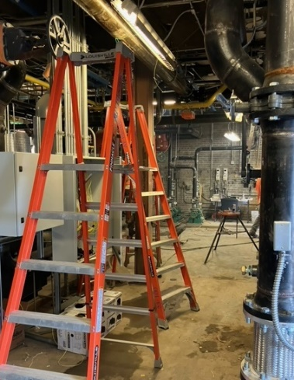  Substantial Completion: | 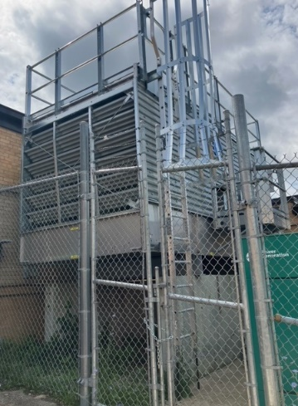  August 1, 2023

NOHS Soffit, Roof, and Metalwork Repairs
Recommendation to reject bid, revise scope and re-bid submitted tonight

Tentative Schedule
Bid/Contracts | TBD
Substantial Completion | TBD

Career Tech Renovation at OCMS
Tentative Schedule:
Re-Bid/Contracts | September 2023
Substantial Completion | June 2024

Career Tech Addition at SOMS
Tentative Schedule:
DDs | August 2023
BG-2, BG-3, CDs | October 2023
Bid/Contracts | November 2023
Substantial Completion | TBD

Site Accessibility at Various Elementary Schools
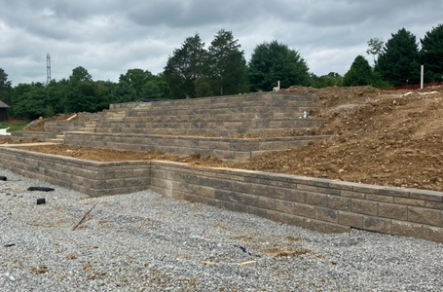
Centerfield:
- Concrete sidewalk from log cabin complete
- Play surface grading complete, equipment installed
- Retaining wall and steps nearing completion, sidewalk complete.
- Play surface near log cabin installed.
- Anticipated completion at all sites: August 8, 2023
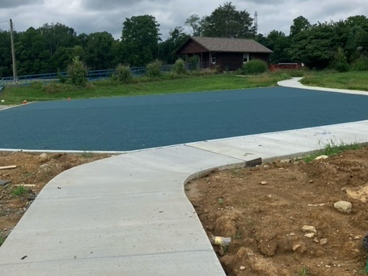
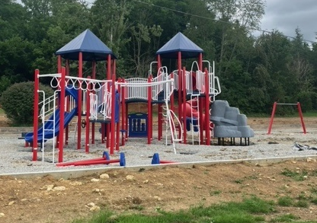

Kenwood
- Existing playground equipment removed, curb installed, sub-surface drainage complete, grading complete, rock installation ongoing pending change order review tonight and equipment delivery.
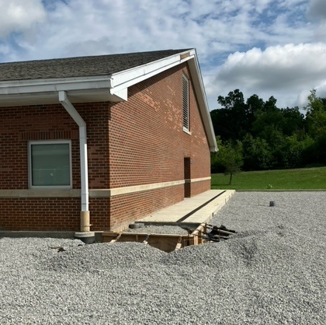
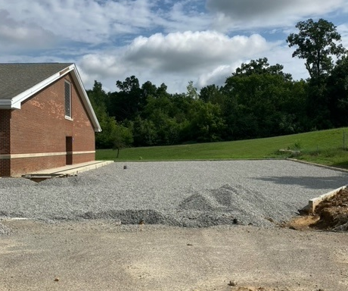

Buckner
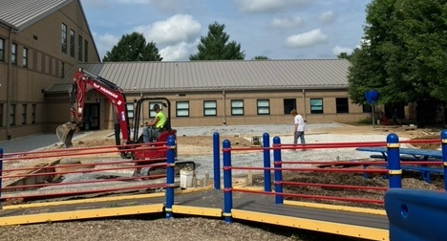
- Rough grading ongoing, curbs complete, mulch placed.
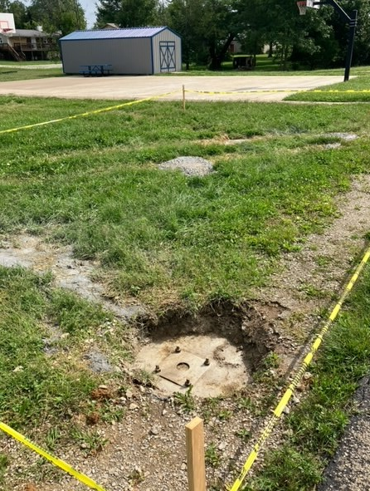
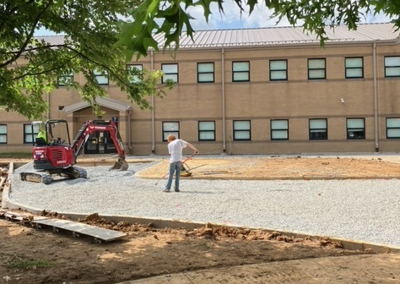
Camden Station
- Mobilization started
- Shade canoy delivery/installation to be completed prior to the first day of school.

Field #2 Renovations at OCHS & NOHS
Design ongoing

Tentative Schedule:

DDs | July 2023
CDs | August 2023
Bid/Contracts | September 2023
Construction Commencement | November 2023
Substantial Completion | July 2023

SOHS Shop Renovation
Welding Shop
Demolition complete, electrical rough-in above ceiling complete, wall patching complete
Core drilling for new waterlines and rough-ins completed.
Spray on acoustic ceiling treatment complete, painting ongoing

Main Lobby Restrooms and corridor
Demolition complete.
Painting in corridor complete, ongoing in restrooms
Ceiling grid installed in restrooms
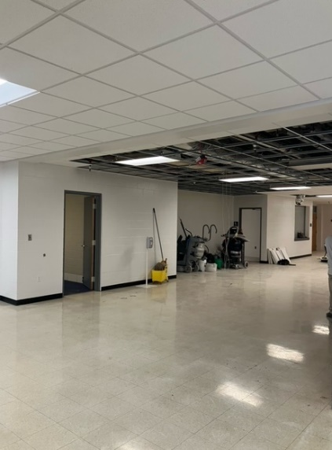
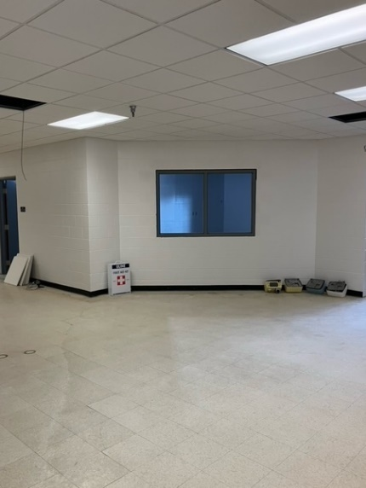
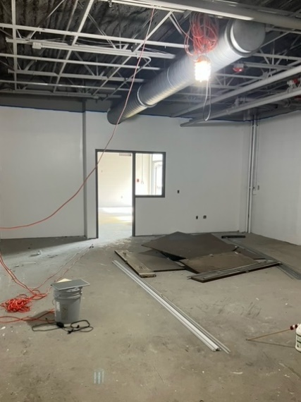

Central Office Interior Renovations & Site Improvements
Design on hold pending Board approval of two story addition.

Anticipated Schedule (w/ addition):
BG-2, BG-3, DDs | June 2023
CDs | September 2023
Bid/Contracts | October 2023
Work Commencement | December 2023
Substantial Completion | December 2024

Minor project Overview
Interior Renovations or Non-Bonded / “Cash” projects. Schedules are anticipated and subject to major project scheduling priority, school holidays and available resources.

Former Liberty Asbestos Abatement & Demolition
On hold pending summer construction schedule.

Flooring Replacement at Various Schools
- Proposal requests for NOHS 600 wing received – work to be completed Fall Break.
- Proposal for counselors’ office for Goshen Elementary School received –scheduled to begin this week.
- Proposal for flooring replacement at OCHS Girls Volleyball locker room and Room 231A received. NTP has been processed. Work scheduled for 1st week of August.

OCHS Auditorium Lighting
- RFP Lighting Consultant to Board – August ‘23

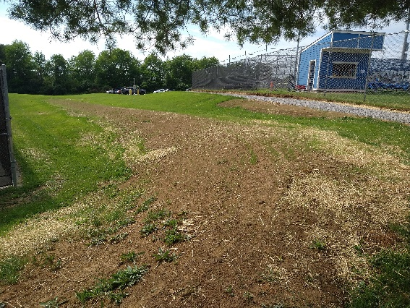
OCHS Berm at Tennis Courts
- Pricing for sidewalk has been received.
- Work to be scheduled as weather permits.

Safety & Security at Middle Schools
- Initial BG-1

LaGrange Elementary School Lower Level Modifications
- Demo completed
- New wall installed, electric rough-in complete
- Painting anticipated to be complete this week.
- Flooring has been ordered
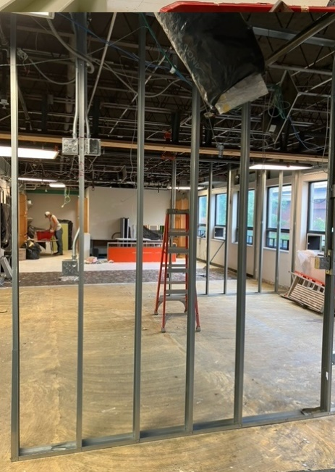
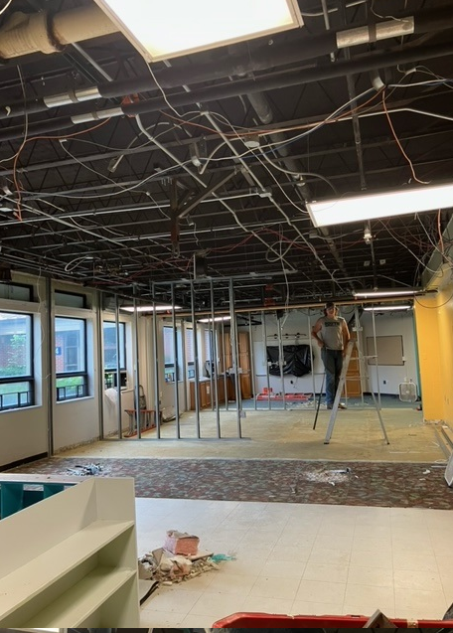
- Ceiling proposals have been requested.

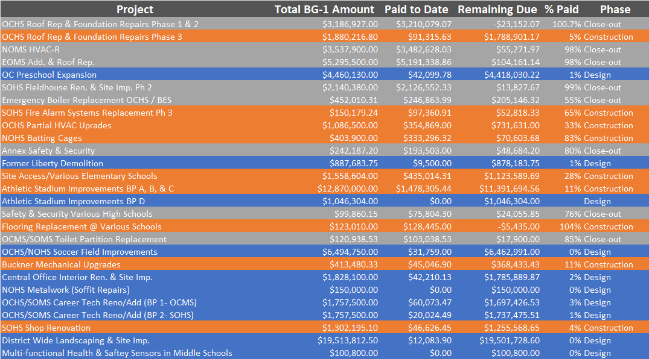

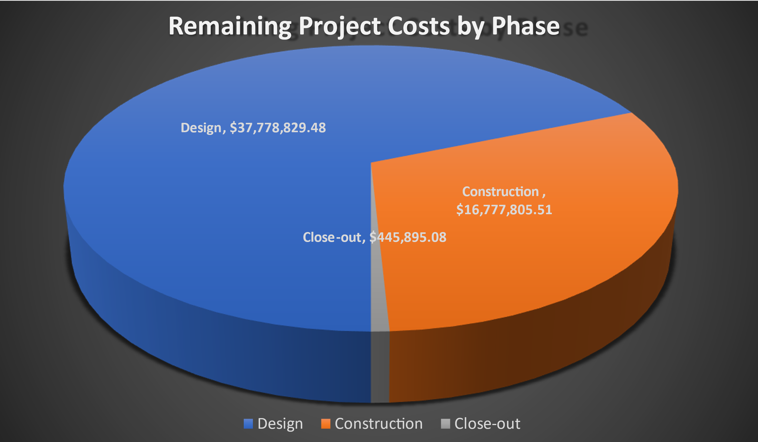

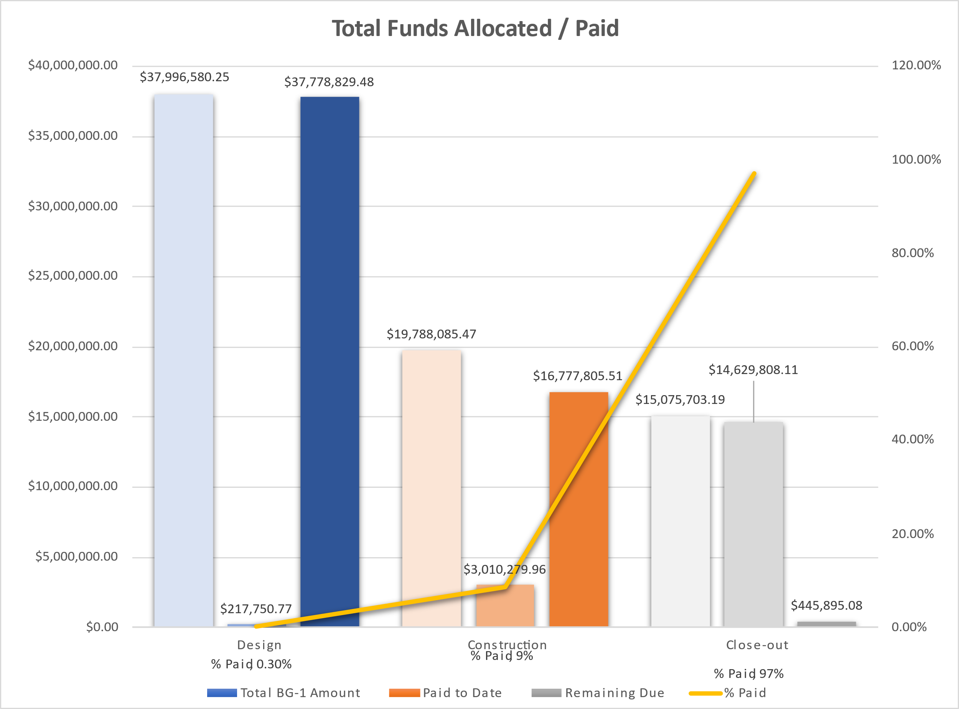

-End of Report

