ACTION ITEM C
July 24, 2023
OLDHAM COUNTY BOARD OF EDUCATION
CONCERN
Consider School Fundraising Requests for Fiscal Year 2024
DISCUSSION
Oldham County schools support comprehensive co-curricular and extra-curricular programs with considerably less financial support from the Board than most districts. Funds are limited for co-curricular and extra-curricular programs because most General Fund income is needed for educational programs and facility needs. Thus, funds necessary to maintain and improve co-curricular and extra-curricular programs are the responsibility of the schools and consequently, their booster clubs.
With regard to these co-curricular and extra-curricular programs, the Board compensates staff, and the schools pay for much of the rest of the related costs, including transportation, student insurance and facility improvements. We are very fortunate to have dedicated parents, coaches, and community suppo1ters (especially the business community) who work extremely hard to ensure that our students enjoy an advantage in all aspects of competition.
Pursuant to OCBE Policy 2030 regarding School Support Groups and Redbook regulations regarding Fundraising, school support groups are submitting their annual fundraising requests as attached.
The gross 2023/2024 fundraising requested is $4,173,752 which is projected to generate net proceeds to schools and support groups amounting to $2,898,963 (69.46%). The table on the next page provides a summary of the fundraising requests, and it is followed by detailed lists of the individual fundraising events by school.
RECOMMENDATION
Approve fundraising requests for the upcoming fiscal year as submitted and authorize the Superintendent to approve on a case-by-case basis, in accordance with appropriate policies and regulations, any additional fundraisers.

On a motion by _______________, seconded by _______________, the Board approved the fundraising requests for the upcoming fiscal year as submitted and authorize the Superintendent to approve on a case-by-case basis, in accordance with appropriate policies and regulations, any additional fundraisers. as presented. ( , )

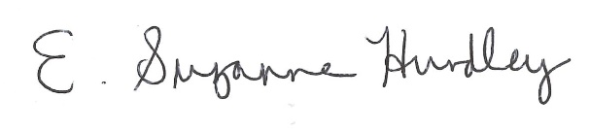
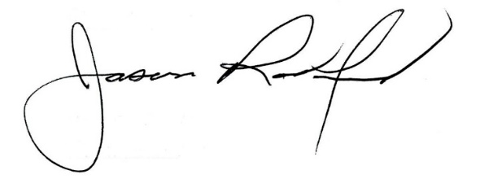

Suzanne Hundley, Board Chair Jason Radford, Superintendent/Secretary

