ACTION ITEM B
JULY 31, 2023
OLDHAM COUNTY BOARD OF EDUCATION
CONCERN
Consider review of FY23 school donations pursuant to Board Policy 3003.
DISCUSSION
Oldham County Board of Education Policy 3003 outlines specific terms pe1taining to the acceptance of donations. It designates the Superintendent and/or his designee to ensure that only donations which meet the criteria set forth in the policy are accepted. Principals may accept individual donations to their schools that do not exceed $2,000.
In addition to Policy 3003, Oldham County Board of Education follows the "Accounting Procedures for Kentucky School Activity Funds," also known as the "Redbook" incorporated by reference into 702 KAR 3:130. The Redbook notes that the principal shall produce a listing of donations for submission to the local board at year-end if the schools are allowed to keep donations at the school.
Following this enclosure are the FY23 donations accepted at the school level.
RECOMMENDATION
Approve the donations from FY23 as presented.

On a motion by _______________, seconded by _______________, the Board approved the donations for FY23 as presented. ( , )

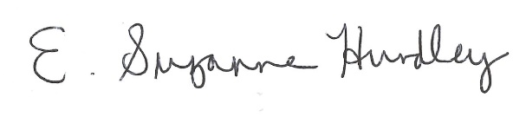
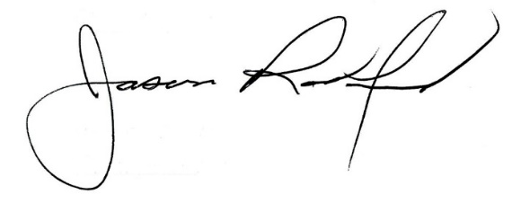

Suzanne Hundley, Board Chair Jason Radford, Superintendent/Secretary

