ENCLOSURE I
July 31, 2023
OLDHAM COUNTY BOARD OF EDUCATION
CONCERN
Consider approval of student requests for early graduation due to hardship.
DISCUSSION
The following students are requesting early graduation due to hardship:
- MH. is a 16-year-old senior at BAHS.
- SJ is a 17-year-old senior at BAHS.
- HH is a 17-year-old senior at BAHS.
- LE is a 17-year-old senior at BAHS.
Documents to support this request follow this enclosure for your review and consideration.
RECOMMENDATION
Approve the student requests for Early Graduation due to hardship.

On a motion by _______________, seconded by _______________, the Board approved the Early Graduation Due to Hardship Request for these students as presented. ( - )

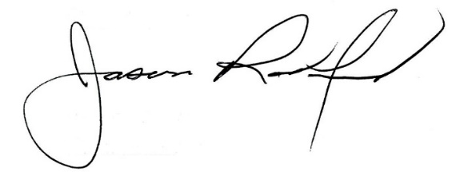
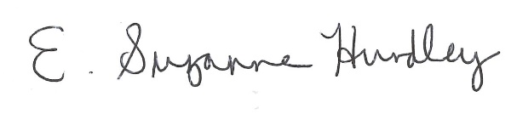

Suzanne Hundley, Board Chair Dr. Jason Radford, Superintendent/Secretary

