ENCLOSURE H
July 31, 2023
OLDHAM COUNTY BOARD OF EDUCATION
CONCERN
Consider approval of allowing Oldham County Schools to obtain contracts for field trip travel with Miller Transportation.
DISCUSSION
Seeking a blanket approval for all Oldham County Schools to be able to contract with Miller Transportation.
Oldham County Schools Administrators will be notified to contact the Oldham County Transportation Department first to see if the department can accommodate their request. If the Oldham County Transportation Department can honor the request, they will do so at the approved field trip rate. If the Transportation Department is unable to accommodate the request, the Oldham County Schools Administrators would then be able to contract with Miller Transportation.
RECOMMENDATION
Approve allowing the Oldham County Schools Administrators the option of contracting with Miller Transportation for field trips during times the Oldham County Transportation Department cannot fulfill their request.

On a motion by _______________, seconded by _______________, the Board approved the option of contracting with Miller Transportation for field trips during times the Oldham County Transportation Department cannot fulfill their request. ( , )

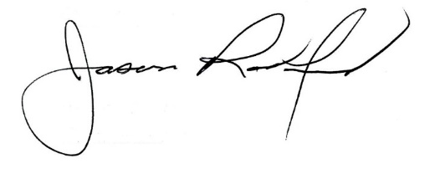
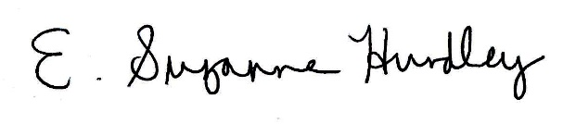

Suzanne Hundley, Board Chair Jason Radford, Superintendent/Secretary

