ENCLOSURE F
July 31, 2023
OLDHAM COUNTY BOARD OF EDUCATION
CONCERN
Consider change in mileage reimbursement rate effective August 1, 2023.
DISCUSSION
At least annually, the Board reviews and adjusts the mileage reimbursement rate paid to employees for district business to the approved state mileage reimbursement rate. The current district mileage reimbursement rate of .53¢ per mile has been in effect since August 1, 2022. The proposed mileage reimbursement rate for FY24 is 46¢, reflective of the most recent state rate. This rate will be updated with the State recommendations throughout the year if necessary.
Oldham County School District uses an accountable IRS plan, which does not allow reimbursement to employees for commuting to their first place of work (or to home at the end of the day), or reimbursement of an amount less than the normal commuting distance if the first place of work is closer than the normal commuting distance. Reimbursement requested for commuting miles would be considered taxable income to employees. This rate will be updated with the State recommendations throughout the year if necessary.
RECOMMENDATION
Effective August 1, 2023, increase the mileage reimbursement rate to .46 cents per mile for mileage for FY24 as presented.

On a motion by _______________, seconded by _______________, and unanimously carried, the Board approved increase the mileage reimbursement rate to .46 cents per mile for FY24 mileage, effective August 1, 2023. ( , )

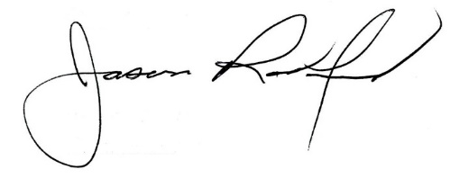
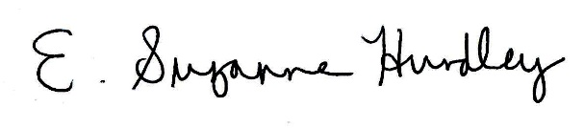

Suzanne Hundley, Board Chair Jason Radford, Superintendent/Secretary

