

FRANCIS PARKER SCHOOL OF LOUISVILLE RENTAL AGREEMENT

This Rental Agreement is entered into on June 14, 2023 between Francis Parker School of Louisville, Inc. (hereinafter referred to as "School"), and North Oldham High School, (hereinafter referred to as "Renter"). Renter hereby rents from School the space known as the Goshen campus Track as the "Premises", and Renter accepts the same, upon the following terms and conditions:

- TERM. The term shall be:
      - Monday July, 17, 2023 through Thursday, August 3, 2023
        - 5:45 – 7:15 p.m.
SCHEDULE:
- July 17, 19, 20, 28, 31 2023
- August 2, 3 2023

- ACCEPTANCE AND SUITABILITY OF THE PREMISES. Renter acknowledges that neither School nor any employee, officer, trustee or other agent or representative of School has made any representation or warranty with respect to the Premises or the suitability or fitness thereof for the conduct of Renter's use. The taking of possession or use of the Premises by Renter for any purpose shall conclusively establish that the Premises were then in satisfactory condition and in conformity with the Rental Agreement in all respects. Renter is leasing the Premises without warranty from School concerning the condition of the site.

- PRICING. Per date, the fee for the Goshen campus Track rental shall be $40. All fees shall be payable to Francis Parker School. Total due: $280.00.

- This signed agreement should be mailed or emailed and inquiries made to Greg Borders at gborders@francisparkerlouisville.org.

- PURPOSE. The purpose of the rental is limited to the Goshen campus Track and parking lot on the Francis Parker School campus.

- USE OF PREMISES. Renter shall use the premises only for the agreed purpose as described above. Renter shall comply with all governmental laws, ordinances and regulations that pertain to or apply to the use of the Premises. Renter agrees to fully comply with School Rental Policies listed below.

- RENTAL POLICIES.
      - There is to be no removal of equipment from any area without prior permission.
      - There is to be no addition of equipment to any area without prior permission.
      - Renter agrees to leave the facilities in the condition in which they were found.
      - Renter agrees to enforce and uphold to all participants the rules of use for the facility, including all health and safety regulations.
      - If the above conditions are not honored, School may terminate this contract without notice.

- REPAIRS AND MAINTENANCE. Upon the expiration or termination of this Rental Agreement, Renter agrees to surrender the Premises in as good and sanitary order, condition, and repair as when received from School; permitted or approved alterations, improvements, additions and reasonable wear and tear excepted. School shall not be required to make repairs or replacements that are necessitated by reason of negligence of the Renter or anyone claiming under the Renter, or by reason of the failure of Renter to perform or observe any conditions of the Rental Agreement, or caused by alterations, addition or improvements made by Renter or anyone claiming under Renter.

- ALTERATIONS AND ADDITIONS. Renter shall not make any alterations or additions to the Premises without the prior written approval of School. Renter agrees to indemnify and hold School harmless from any and all liabilities, claims, liens, encumbrances and judgments created or suffered in connection with labor, services or materials furnished in connection with any alterations or additions which Renter causes to be made to the Premises.

- INDEMNIFICATION.

- School shall not be liable for death, injury, or damage of any kind to persons or property from any cause whatsoever by reason of the use and occupancy of the Premises by Renter, its agents, servants, employees, clients or invitees, and Renter hereby waives all claims and causes of actions against School or any of its officers, directors, trustees or employees for any such injury or damage as well as for consequential damages. Neither School nor any of its officers, directors, trustees or employees shall be liable to Renter, its agents, servants, employees, or invitees for any damage, loss, or injury caused by the condition or design of, or any defect in, the Premises, unless the loss, damage, or injury is the result of the willful misconduct of School or its duly authorized employees, officers, or agents. The provisions of this section shall survive the termination of this Lease.

- Renter agrees to indemnify School and each of its officers, directors, trustees or employees and hold each of them harmless and free from and against any and all liability, loss, cost, expense, or obligation (including, without limitation, reasonable attorneys' fees, court costs, and other expenses incurred by School) on account of or arising out of, and this Rental Agreement is made on the express condition that neither School nor any of its officers, directors, trustees or employee shall be liable for, or suffer loss or incur any liability by reason of, injury to or death of a person or damage to or loss of use of property, from whatever cause in any way connected with the condition or use of the Premises or the condition of use of personal property or fixtures on or about the Premises. This indemnity shall also apply to activities by third parties.

- ASSIGNMENT AND RENTING. Renter shall not voluntarily, or by operation of law, assign, sublet, transfer, or otherwise transfer or encumber all or any part of Renter's interest in this Agreement or in the Premises, or rent said Premises or any part thereof. Any attempted assignment, transfer, sublease, encumbering or renting shall be void and constitute a breach of this Agreement.

- WAIVER OF BREACH. Waiver by School of any breach of any term, covenant or condition contained in this Rental Agreement shall not be deemed to be a waiver of any subsequent breach of the same or of any other term, covenant or condition contained in the Rental Agreement. School’s consent to, or approval of, any act shall not be deemed to render unnecessary the obtaining of School's consent to or approval of any subsequent act by any Renter. The acceptance of rent or other sums payable hereunder by School shall not be a waiver of any preceding breach by Renter of any provision hereof, other than failure of Renter to pay the particular rent or other sums so accepted, regardless of school’s knowledge of such preceding breach at the time of acceptance of such rent or sums.

- WAIVER OF CLAIMS. Renter hereby irrevocably waives on behalf of itself, its successors and assigns and all persons claiming through it, any claim which Renter may assert against School for any costs, expenses, or claims not specifically listed herein incurred by Renter in connection with any termination, either by operation of law or otherwise, of this Rental Agreement. Renter specifically acknowledges that this Rental Agreement may be pleaded as a defense and a bar to any such claim. Renter agrees that all participants will be required to sign a separate waiver before checking into the Dormitory and participating in activities under this rental agreement.

- INSURANCE REQUIREMENTS. The Rental shall provide to the School a copy of the General Liability Insurance in the amount of $1,000,000 for injuries to any one person and $100,000 for property damage.

- FORCE MAJEURE. If due to acts of God, insurrection, fire, elements, national emergency, or any other similar cause outside of the reasonable control of either party to this Agreement (“Force Majeure”) the performance of either party under the terms of this Agreement is delayed or made impossible, the parties agree that such cancellation, postponement, or failure to perform shall not be considered a breach of this Agreement. In such event, however, the parties agree to use reasonable efforts to renegotiate this Agreement under similar terms.

- SURVIVAL. The provisions of Sections 9, 11, and 12 shall survive the termination of this Lease.

- SEVERABILITY. If any term, covenant, condition or provision of this Agreement, or the application thereof to any person or circumstance, shall to any extent be held by a court of competent jurisdiction or rendered by the adoption of a statute by the State of Washington or the United States of America invalid, void or unenforceable, the remainder of the terms, covenants, conditions or provisions of this Agreement, or the application thereof to any person or circumstance, shall remain in full force and effect and shall in no way be affected, impaired or invalidated thereby.

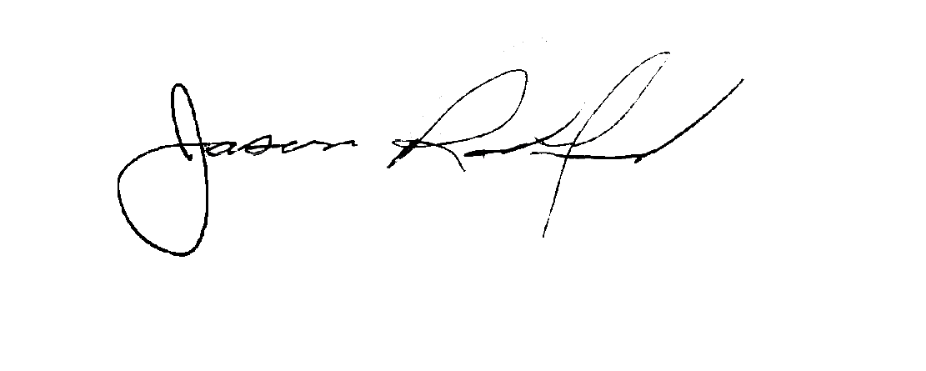
"SCHOOL" "RENTER"
Francis Parker School of Louisville _________________________________________

By: By:
Greg Borders, Associate Head of School Superintendent

Date: Date: July 12, 2023

gborders@francisparkerlouisville.org matthew.walker2@oldham.kyschools.us

502-795-3369 telephone number: 502-228-0158

