MINUTES
July 31, 2023
OLDHAM COUNTY BOARD OF EDUCATION
CONCERN
Consider Approval of Meeting Minutes.
DISCUSSION
The draft minutes of the June 26, 2023, Regular Board Meeting and the July 10, 2023, Special Called meetings are available for review and approval.
RECOMMENDATION
Approve the minutes of the following meetings as presented.
June 26, 2023 – Regular Board Meeting
(1) Suzanne Hundley, Chairperson, (2) Larry Dodson, Board Vice Chair; and (3) Joe Dennis, Board Member, (4) Carly Clem, Board Member (5) Allison Sheffer, Board Member, and Dr. Jason Radford, Superintendent and Secretary to the Board were present.
July 10, 2023 – Special Called Meeting
(1) Suzanne Hundley, Chairperson, (2) Larry Dodson, Board Vice Chair; and (3) Joe Dennis, Board Member, (4) Carly Clem, Board Member (5) Allison Sheffer, Board Member, and Dr. Jason Radford, Superintendent and Secretary to the Board were present.

On a motion by _______________, seconded by _______________, and unanimously carried, the Board approved the minutes of the June 26, 2023, Regular Board Meeting. (_,_)
On a motion by _______________, seconded by _______________, and unanimously carried, the Board approved the minutes of the July 10, 2023, Special Called Work Session. (_,_)

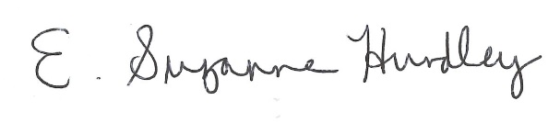
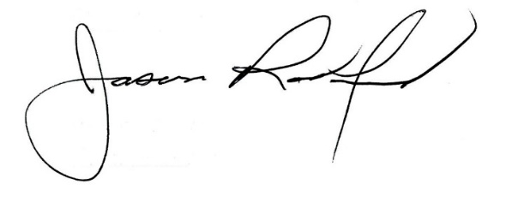

___________________________________ ______________________________
Suzanne Hundley, Board Chair Jason Radford, Superintendent/Secretary

