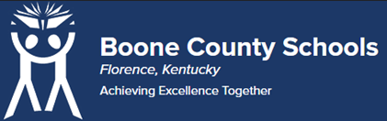
Boone County Board of Education Members
Mrs. Karen Byrd, Board Chair
Mr. Jesse Parks, Vice Chair
Dr. Maria Brown
Mrs. Carolyn Wolfe
Mrs. Cindy Young

Mr. Matthew Turner, Superintendent

Board Memo

DATE: 06/16/2023

AGENDA ITEM DETAILS:
School/Department
Ignite Institute
Product Vendor or Grant Issuer
Gateway Community and Technical College
Product or Grant Name
Dual Credit Advisor
Date/Term (Beginning and End Dates/Year)
07/01/2023 to 06/30/2024

APPLICABLE BOARD POLICY:
N/A

DESCRIBE USE OF CONTRACT/PURCHASE/AGREEMENT
The purpose of the agreement is to facilitate cooperation between the College and the District In meeting the educational needs of the students of the district. The dual credit advisor (DCA) will provide advising enrollment services to the dual credit students at Ignite Institute. Strategic Plan Connection – Goal 1: World Class Education. “Boone County Schools will ensure all students will receive rigorous and engaging instruction” (1B)

FUNDING FOR PURCHASES AND OTHER REQUESTS:
Total Cost
$9,000.00
Funding Source
Ignite Budget
*If more than one funding source, list below along with amount or percent for each source

IF THIS IS A GRANT, ENTER AMOUNT TO BE AWARDED:
N/A

RECOMMENDATION:
I recommend that the board approve this memorandum of agreement as presented.

Dr. Jim Detwiler, Deputy Superintendent/CAO

CONTACT PERSON:
Bill Hogan, Director of Innovative Programs

