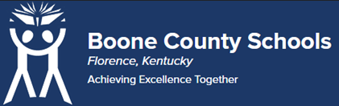
Boone County Board of Education Members
Mrs. Karen Byrd, Board Chair
Mr. Jesse Parks, Vice Chair
Dr. Maria Brown
Mrs. Carolyn Wolfe
Mrs. Cindy Young

Mr. Matthew Turner, Superintendent

Board Memo

DATE: 06/20/2023

AGENDA ITEM DETAILS:
School/Department
Boone County Schools, Special Education
Product Vendor or Grant Issuer
The Office of Vocational Rehabilitation and Education and Labor Cabinet
Product or Grant Name
Community Work Transition Program
Date/Term (Beginning and End Dates/Year)
07/01/2023 to 06/30/2024

APPLICABLE BOARD POLICY:
N/A

DESCRIBE USE OF CONTRACT/PURCHASE/AGREEMENT
Partnership through Boone County Schools, the Office of Vocational Rehabilitation, and the University of Kentucky (HDI) for reimbursement for transaction services provided through our Boone County Employment Specialists. Strategic Connection – Goal 1: World Class Education – “Provide and encourage diverse college, career, and service pathways that meet the full breadth of our students’ passions, pursuits, and life readiness” (1C)

FUNDING FOR PURCHASES AND OTHER REQUESTS:
Total Cost
$0.00
Funding Source
N/A
*If more than one funding source, list below along with amount or percent for each source

IF THIS IS A GRANT, ENTER AMOUNT TO BE AWARDED:
N/A

RECOMMENDATION:
I recommend that the board approve this memorandum of agreement as presented.

Dr. Jim Detwiler, Deputy Superintendent/CAO

CONTACT PERSON:
Jodi Hall, Director of Special Education

