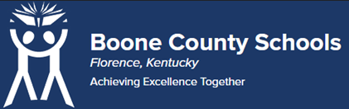
Boone County Board of Education Members
Mrs. Karen Byrd, Board Chair
Mr. Jesse Parks, Vice Chair
Dr. Maria Brown
Mrs. Carolyn Wolfe
Mrs. Cindy Young

Mr. Matthew Turner, Superintendent

Board Memo

DATE: 6/29/2023

AGENDA ITEM DETAILS:
School/Department
Boone County Schools, Learning Support Services
Product Vendor or Grant Issuer
Building Institute Association of Northern Kentucky
Product or Grant Name
Skilled Trades Program
Date/Term (Beginning and End Dates/Year)
July 1, 2023 – June 30, 2024

APPLICABLE BOARD POLICY:
N/A.

DESCRIBE USE OF CONTRACT/PURCHASE/AGREEMENT
This Memorandum of Agreement is between the Building Institute of Northern Kentucky and Boone County Schools. Boone County Schools are going to be sending forty-four students to the Building Institute this coming year for the students first year in skilled trades studies. We are sending approximately twenty-two students in the morning session and twenty-two I the afternoon. This MOU lays out the financial obligation of the district for the program for the year. Strategic Plan Connection – Goal 1: World Class Education. “Boone County Schools will ensure all students will receive rigorous and engaging instruction” (1B).

FUNDING FOR PURCHASES AND OTHER REQUESTS:
Total Cost
$75,000.00
Funding Source
LAVEC
*If more than one funding source, list below along with amount or percent for each source

IF THIS IS A GRANT, ENTER AMOUNT TO BE AWARDED:
N/A

RECOMMENDATION:
I recommend that the board approve this memorandum of agreement as presented.

Dr. Jim Detwiler, Deputy Superintendent/CAO

CONTACT PERSON:
Bill Hogan, Director of Innovative Programs

