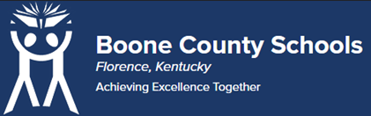
Boone County Board of Education Members
Mrs. Karen Byrd, Board Chair
Mr. Jesse Parks, Vice Chair
Dr. Maria Brown
Mrs. Carolyn Wolfe
Mrs. Cindy Young

Mr. Matthew Turner, Superintendent

Board Memo

DATE: 06/27/2023

AGENDA ITEM DETAILS:
School/Department
Conner Middle School
Product Vendor or Grant Issuer
AccuTrain Corp. with LOL Consulting LLC
Product or Grant Name
Responsibility-Centered Discipline Training: “Give ‘em Five”
Date/Term (Beginning and End Dates/Year)
August 14th and 15th 2023

APPLICABLE BOARD POLICY:
Strategic Connection – Goal 2: “Collaborate with Learning Support Services to provide quality professional learning and targeted investment in staff capacity.” (D1)

DESCRIBE USE OF CONTRACT/PURCHASE/AGREEMENT
Presented by Joseph Cope, M.Ed, RCD training can have a transformative impact on student behavior, teacher morale and school culture. To help staff on how to handle challenging moments in the classroom in a way that grows students’ self-control and promotes a more positive school climate. Includes Workbooks 1 & 2 for 70 participants for two 6-hour days of training.

FUNDING FOR PURCHASES AND OTHER REQUESTS:
Total Cost
$14,450.00
Funding Source
ESSER
*If more than one funding source, list below along with amount or percent for each source

IF THIS IS A GRANT, ENTER AMOUNT TO BE AWARDED:
N/A

RECOMMENDATION:
I recommend that the board approve this agreement as presented.

Dr. Jim Detwiler, Deputy Superintendent/CAO

CONTACT PERSON:
Dr. Michael Poiry, Assistant Superintendent for Learning Support Services/Middle & High Schools

