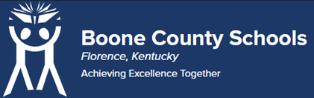
Boone County Board of Education Members
Mrs. Karen Byrd, Board Chair
Mr. Jesse Parks, Vice Chair
Dr. Maria Brown
Mrs. Carolyn Wolfe
Mrs. Cindy Young

Mr. Matthew Turner, Superintendent

Board Memo

DATE: 5/23/2023

AGENDA ITEM DETAILS:
School/Department
Boone County Schools
Product Vendor or Grant Issuer
Instructure
Product or Grant Name
Mastery Connect, Case and Bank, Grades 2-12
Date/Term (Beginning and End Dates/Year)
07/15/2023 – 07/14/2024

APPLICABLE BOARD POLICY:
N/A

DESCRIBE USE OF CONTRACT/PURCHASE/AGREEMENT:
Mastery Connect is an online teacher tool and student assessment platform. It allows teachers to determine efficiently and effectively what your child knows and doesn't know based on the core standards. Students can take a variety of different assessments and receive results instantly. Strategic Plan Connection – Goal 1: World Class Education. “Implement a Multitiered Systems of Supports (MTSS) that meets the learning needs of struggling learners.” (1B3)

FUNDING FOR PURCHASES AND OTHER REQUESTS:
Total Cost
$269,485.40
Funding Source
Textbook Fund and Title II
*If more than one funding source, list below along with amount or percent for each source
Textbooks Fund: $196,724.31, Title II: $72,761.09

IF THIS IS A GRANT, ENTER AMOUNT TO BE AWARDED:
N/A

RECOMMENDATION:
I recommend that the board approve this agreement as presented.

Dr. Jim Detwiler, Deputy Superintendent/CAO

CONTACT PERSON:
Mary Ann Rankin, Director of Technology / Diane Bodenbender

